# Historical Trends and Emerging Environmental Pressures on Nursery Function in French Estuaries: An Integrated Approach Combining Contaminants, Water Quality, Benthic Fauna and Fish Communities

## Introduction

Comparaison de la qualité de la fonctionnalité de nourriceries des trois plus grands estuaires français (Gironde, Loire et Seine) et de leurs tendances d’évolution.

Diagnostic basé sur l’étude des paramètres impliqués dans la qualité de la fonctionnalité de nourricerie des estuaires : paramètres physico-chimiques, contamination, diversité et qualité écologique des communautés de faune benthique et de poissons (+ indices de condition poisson ?)

« La fonction de nourricerie est l’une des principales assurées par les estuaires de la Mer du Nord et ceux de l’Atlantique européen (Whitfield & Elliott, 2002 ; Franco et al, 2008). Une fraction importante de l'ichtyofaune estuarienne est originaire du milieu marin et constitue la guilde des espèces migrantes marines, qui naissent en mer et peuvent pénétrer dans les estuaires de façon plus ou moins régulière puis retournent en mer pour leurs stades ultérieurs de développement. Le bar (*Dicentrarchus labrax*) et la sole (*Solea solea*), d'origine marine, dépendent plus étroitement au stage juvénile des habitats abrités estuariens, avec des niveaux d’abondance pouvant être très élevés pour les stades juvéniles. Ce sont ces espèces de la guilde des espèces marines migrantes estuariennes-dépendantes (MMD) que nous avons choisies pour représenter les habitats de la fonction de nourricerie de poissons marins. Nous nous sommes particulièrement focalisés sur les groupes d’âge G0 (1ère année de vie) et G1 (2ème année de vie) de ces espèces, correspondants aux stades de vie pour lesquels les estuaires sont des habitats préférentiels (Bacq *et al.*, 2013).

## Material and methods

### Study sites

### Contamination of biota by legislated compounds

#### Data source

Concentrations of various contaminants were measured in bivalves collected from three major French estuaries (Gironde, Loire, and Seine) over the period 1979 to 2024, as part of the ROCCHMV monitoring program. In the Gironde estuary, the Pacific oysters (*Crassostrea gigas*) was monitored. In the Seine estuary, the blue mussel (*Mytilus edulis*) was studied. In the Loire estuary, the blue mussel was initially monitored, and, from 2017 onward, *oysters* were also included in parallel. Sampling was conducted in the most saline zones of each estuary, near their respective mouths (Figure 1).

|  |  |  |
| --- | --- | --- |
|  |  |  |
| Figure 1 - Map of sampling points for the ROCCHMV program. The numbers indicate the number of years these points have been monitored. | | |

#### Data transformations

When multiple measurements were available for the same year, the annual median value was used. Values under limit of detection were replaced by zero value. The similarity in bioaccumulation potential between mussels and oysters was assessed based on differences in their contamination levels. Where differences were observed, such as those documented for several metals (Ifremer, 2024), all concentrations were expressed in “mussel equivalents” using an oyster-to-mussel conversion factor. This factor was calculated for each metal as the ratio of median contamination levels in oysters to those in mussels, based on seven years (2017-2024) of parallel monitoring in the Loire estuary. The resulting conversion factors were 0.634 for mercury, 0.718 for cadmium, 0.898 for lead, and 0.036 for copper.

#### Data analysis

Recent trends were estimated using the last 15 years of time series data, applying Spearman’s rank correlation coefficient (ρ). Statistical significance of the correlations was tested using the cor.test function from the {stats} package in R. For each estuary and each compound, the correlation coefficient and its associated p-value were used to evaluate the presence and direction of recent trends.

Long-term trends were assessed using the Kruskal-Wallis rank sum test (kruskal.test, {stats} package), based on contamination data from the first and last five-year periods, for compounds with more than 20 years of monitoring data. To compare contamination levels between compounds and estuaries, median values were calculated for both periods. For compounds monitored for fewer than 20 years, long-term trends were not estimated. Instead, contamination levels were compared using median values calculated over the entire monitoring period.

When a decreasing trend was observed, the time required for concentrations to fall below the EQS was estimated by comparing values from the first and last years of the monitoring period. Assuming a linear rate of decline, this approach allowed for projection of the time needed to reach compliance with the EQS.

#### Studied compounds

The full list of contaminants monitored under the ROCCHMV program is available on the “Envlit” website maintained by Ifremer (<https://envlit.ifremer.fr/Surveillance-du-littoral/Contaminants-chimiques/Contaminants-suivis>). For the present study, a subset of compounds was selected and is listed in Table 1, based on the following criteria: (1) inclusion in European or national regulatory framework with established thresholds for human health and ecotoxicological risk in biota (European Commission, 2013; legifrance.gouv, 2023; OSPAR, 2023); and (2) detection above analytical limits in the present dataset. These criteria ensure that the selected compounds are ecologically and toxicologically relevant and reflect the contamination levels to which juvenile organisms and their prey are exposed.

Table 1 summarizes the main sources and ecotoxicological effects as synthetized from (Ifremer, 2021). The table also presents the relevant legislative thresholds, specifying their regulatory context (human health or ecotoxicology), the biological matrix of reference (primarily bivalves or fish), and the legislative source.

Three legislated heavy metals have been studied (mercury, cadmium, and lead). Copper was also included due to its historical significance as a pollutant in the Gironde estuary (Ifremer, 2024). Two types of organochlorine (OC) pesticides are under legislative thresholds: γ**-HCH** (**or Lindane)** and so called DDT total (sum of isomers p,p'-DDT (4,4’-DDT), o,p’-DDT (2,4’-DDT), p,p'-DDE (4,4’-DDE), p,p'-DDD (4,4’-DDD)). Eight **Polycyclic Aromatic Hydrocarbon** (PAH) are under OSPAR legislation: fluoranthene, benzo(a)pyrene (abr. benzo-pyr.), anthracene, naphthalene, phenanthrene, pyrene, benzo(a)anthracene (abr. benzo-anthra.), and benzo(g,h,i)perylene (abr. benzo-peryl.). Seven indicator congeners of the polychlorinated biphenyls (PCB) family are under OSPAR legislation: CB 28, CB 52, CB 101, CB 118, CB 138, CB 153, CB 180. **Dioxins and dioxin-like compounds are under a European Commission legislation under the form of a weighted sum of PCDD + PCDF + PCB-DL expressed in toxic equivalents concentrations (see SI for details**). Two types of brominated flame retardant were studied: the three isomers of HBCDD (hexabromocyclododecane) and the sum **of** Polybrominated diphenyl ethers (PBDE) **congeners 28, 47, 99, 100, 153 and 154. Two emergent compounds were studied more recently: a perfluorinated compound (**perfluorooctane sulfonate, PFOS), and an **organostannic compound (tributyltin cation).**

Table 1 – Characteristics and thresholds in biota for the selected contaminants and the associated evaluation from ROCCHMV program.  
Threshold type related to human health: QS(HH) (EU Quality Standard for Human Health), EC MPC (European Commission maximum permissible concentrations).   
Threshold types related to ecotoxicology: EQS (EU Ecological Quality Standard), EAC (Environmental Assessment Criteria: North-Est Atlantic OSPAR equivalent of EQS), NQE (Norme de Qualité Environnementale: French equivalent of EQS), VGE (Valeurs Guide Environnementales: French equivalent of EQS for bivalves).   
Matrix abbreviations: f.: fish, c: crustaceans, m: molluscs, b: bivalves.   
¤ long term evolution, last short term evolution, deviation from limit value (blue: [0-50%[, green: [50-100%[, yellow:[100-150%[, orange: [150-300%[, red: [300-500%[, black: > 500%)

|  |  |  |  |  |  |  |  |  |  |  |  |
| --- | --- | --- | --- | --- | --- | --- | --- | --- | --- | --- | --- |
|  |  |  |  |  |  |  |  | EVALUATION¤ | | | |
| Family | Contaminant | Main Sources | Ecotoxicological Effects | Time series | Threshold | Matrix | Type (source) | Gironde | Loire | Seine |
| Historically monitored heavy metals | Mercury (Hg) | Coal combustion, mining | Neurotoxicity, reproduction impairment | 1979-2024 | 500 ng/g ww | b | EC MPC (OSPAR, 2023a) | → → 🔵 | → → 🔵 | → → 🔵 |
| Cadmium (Cd) | Mining, batteries, pigments, electroplating | Kidney damage, growth inhibition | 1979-2024 | 1000 ng/g ww | b | EC MPC (OSPAR, 2023a) | ↓ → 🟠 | ↓ ↓ 🔵 | ↓ → 🔵 |
| **Lead (Pb)** | Leaded fuels, paint, batteries | Neurological and developmental toxicity | 1979-2024 | 1500 ng/g ww | b | EC MPC (OSPAR, 2023a) | → → 🔵 | ↓ ↓ 🔵 | → → 🔵 |
| **Copper (Cu)** | Antifouling paints, mining, plumbing | Oxidative stress, enzyme disruption | 1979-2024 | - | - | - | - | - | - |
| **Organochlorin pesticides** | DDT total | Insecticide (historical), degradation product and main metabolite | Endocrine disruptor, reproductive impact, hepatic toxicity, potential carcinogen | 1979-2023 | 1282 ng/g ww | b | VGE (Légifrance, 2023 Tableau 99) | ↓ → 🔵 | ↓ → 🔵 | ↓ ↓ 🔵 |
| **Lindane** or γ**-HCH** | Insecticide (historical) | Neurotoxicity, reproduction effects | 1982-2023 | 0.29 ng/g ww | b | EAC (Ineris, 2022) | ↓ ↓ 🔵 | ↓ NA 🔵 | ↓ ↓ 🔵 |
| **Polycyclic aromatic hydrocarbon (PAH)** | **Fluoranthene** | Combustion, oil spills | Carcinogenicity, oxidative stress, DNA binding, nervous system effects, phototoxicity | 1994-2024 | 110 ng/g dw | b | EAC (OSPAR, 2023b) | → → 🔵 | ↓ → 🔵 | ↓ → 🔵 |
| **Benzo(a)pyrene** | 600 ng/g dw | b | EAC (OSPAR, 2023b) | → ↓ 🔵 | → → 🔵 | → → 🔵 |
| **Pyrene** | 100 ng/g dw | b | EAC (OSPAR, 2023b) | → → 🔵 | ↓ → 🔵 | ↓ → 🔵 |
| **Benzo(a)anthracene** | 80 ng/g dw | b | EAC (OSPAR, 2023b) | → → 🔵 | → → 🔵 | → → 🔵 |
| **Benzo(g,h,i)perylene** | 110 ng/g dw | b | EAC (OSPAR, 2023b) | → ↑ 🔵 | ↓ → 🔵 | → → 🔵 |
| **Anthracene** | 290 ng/g dw | b | EAC (OSPAR, 2023b) | → → 🔵 | → → 🔵 | → → 🔵 |
| **Naphtalene** | 340 ng/g dw | b | EAC (OSPAR, 2023b) | → → 🔵 | → ↓ 🔵 | ↓ ↓ 🔵 |
| **Phenanthrene** | 1 700 ng/g dw | b | EAC (OSPAR, 2023b) | → → 🔵 | ↓ → 🔵 | ↓ → 🔵 |
| Polychlorinated Biphenyls indicators (PCBi) | **PCB 28** | Dielectric fluids, sealants | Endocrine disruptors, immunotoxicity, reproductive disorders, potential carcinogens | 1988-2024 | **67 ng/g lw** | b | EAC (OSPAR, 2023d) | ↓ → 🔵 | ↓ → 🔵 | ↓ → 🔵 |
| **PCB 52** | **108 ng/g lw** | ↓ → 🔵 | ↓ → 🔵 | ↓ ↓ 🟡 |
| **PCB 101** | **121 ng/g lw** | → → 🟢 | ↓ → 🔵 | ↓ → 🔴 |
| **PCB 118** | **25 ng/g lw** | → → 🟠 | ↓ → 🟠 | ↓ ↓ ⚫ |
| **PCB 138** | **317 ng/g lw** | ↓ → 🔵 | ↓ → 🔵 | ↓ → 🟠 |
| **PCB 153** | **1585 ng/g lw** | → → 🔵 | ↓ → 🔵 | ↓ → 🟢 |
| **PCB 180** | **469 ng/g lw** | ↓ → 🔵 | ↓ → 🔵 | ↓ → 🔵 |
| **Dioxins and dioxin-like compounds (DLC)** | **Weighted sum of PCDD + PCDF + PCB-DL** | By-product of combustion, pesticide production, paper bleaching | Carcinogenicity, endocrine disruption | 2008-2024 | **0.0065 ng/g TEQ** | f, c, m | QS(HH) (European Commission, 2013) | → 🔵 | ↑ 🔵 | → 🟠 |
| Brominated flame retardant | **HBCDD isomers: α-HBCDD, β-HBCDD and γ-HBCDD** | Flame retardant in polystyrene, textiles | Endocrine disruption, neurotoxicity, embryonic mortality in fish | 2008/2018-2024 | 167 ng/g ww | f | EQS (European Commission, 2013) | → 🔵  → 🔵  → 🔵 | ↓ 🔵  ↑ 🔵  → 🔵 | ↓ 🔵  → 🔵  → 🔵 |
| **Sum of PBDE** | Flame retardants in plastics, textiles, foams, electronic equipment | Endocrine disruption, neurotoxicity, reproductive effects, immunotoxicity | 2008-2024 | 0.0085 ng/g ww | f | EQS (European Commission, 2013) | ↓ ⚫ | ↓ ⚫ | ↓ ⚫ |
| Perfluorinated compounds | Perfluorooctane sulfonate (PFOS) | Stain repellents, firefighting foams | Endocrine disruption, liver toxicity | 2010-2024 | 9.1 ng/g ww | f | EQS (European Commission, 2013) | → 🔵 | → 🔵 | ↓ 🔵 |
| **Organostannic compounds** | Tributyltin cation | Antifouling paints | Imposex in gastropods, endocrine disruption | 2019-2024 | 12 ng/g dw | b | EAC (Ineris, 2022) | → 🔵 | → 🟢 | → 🟢 |

### Contamination of biota and sea water by emerging biocides

As part of the revision of the national list of Specific Pollutants of Ecological Status (PSEE), aimed at identifying relevant substances for monitoring in coastal environments, Ifremer investigated 102 emerging organic substances (i.e., not currently regulated for the marine environment), including different types of biocides (Amouroux *et al.*, 2025). These measurements were carried out in 2021 and 2022, alongside ROCCHMV sampling, using integrative matrices—namely, bivalves and passive samplers (POCIS)—to facilitate the detection of these substances. The use of passive samplers is particularly suited for targeting organic compounds with low hydrophobicity, which are expected to exhibit limited bioconcentration and bioaccumulation in marine organisms. In addition, the compounds studied are generally less persistent than those subject to regulation, making them more susceptible to seasonal variation.

Sampling sites and periods were selected to coincide with locations and times of known contaminant inputs (i.e., related to usage patterns). The emerging compounds selected for this study (see Table 5) include those quantified in at least one of the three estuary (Seine: Villerville site; Loire: Montoir-Ponton site; Gironde: Pontaillac site) and quantified in seawater (2 herbicides) or in bivalves (7 antifouling agents, 7 fungicides, 1 insecticide and 14 herbicides).

To determine whether the estuaries were more contaminated than the French coastline overall, annual mean concentrations were calculated at the national level and compared with the corresponding yearly means observed in each estuary. To assess the potential environmental risk associated with these contamination levels, observed concentrations were also compared to Predicted No Effect Concentration (PNEC) values. Another way to evaluate whether contamination levels exceeding the national average may reflect an environmental risk was to consider the ranking of the compounds in the Emergent’Sea program. This ranking is based on the frequency of quantification of each compound, as well as the extent and frequency of PNEC exceedances.

### Benthic invertebrate fauna

#### Data sources

Benthic invertebrate fauna was studied using data from:

* The REBENT program for the Gironde estuary (2007, 2008, 2012, 2016, 2017, 2020, 2023), the Seine estuary (2007, 2014, 2017, 2020, 2023), and the Loire estuary (2020).
* The EDF & INRAE French program of monitoring of the aquatic environment linked to the operation of the Cordemais energy production unit for the Loire estuary (2008-2024).

The **REBENT** (Réseau de surveillance benthique) French program, used also in the **DCE-Benthos** (part of the **Directive Cadre sur l’Eau** - Water Framework Directive, or WFD) European program, proceed to a **benthic macrofauna** monitoring in coastal and transitional waters. These programs aim to assess the **ecological quality of marine and coastal environments** based on the benthic community structure, which responds to pressures like eutrophication, pollution, sediment disturbance, and climate change.

The EDF program aims at monitoring the impact of discharges from cooling circuits in the immediate vicinity of the Cordemais power plant site, in compliance with legislation requiring hydrobiological monitoring of the environment.

* Mesh sieves: 1 mm square for both programs
* Seasonality:
  + REBENT: 2007 (04-05), other years (9,10,11)
  + EDF: spring (05-06-07) and autumn (10-11)
  + => only autumn was kept
* Salinity:
  + Loire EDF: oligohaline (1.5-5)
  + Loire REBENT:
  + Seine REBENT : delete points at the mouth of the estuary (011-P-049, 011-P-050)

#### Yearly ecological indices

French methodology DCE macro-invertebrates (Blanchet *et al.*, 2025)

* **Abundance/Density: total number of individuals per m²**
* **Taxonomic Composition: p**resence and dominance of specific taxonomic groups (e.g., polychaetes, mollusks, crustaceans) (sensitive to pollution and organic enrichment)
* **Ecological Quality Ratios (EQR)**
  + **EQR-AMBI (AZTI Marine Biotic Index):**

**AMBI is a score of anthropic disturbance response** (Borja, Franco et Pérez, 2000; Borja et Muxika, 2005)

First needs to assign species to **5 ecological groups** from sensitive to opportunistic, reflecting their tolerance to organic enrichment and pollution (GI: sensitive species; GII: indifferent species; GIII: tolerant species; GIV: second-order opportunistic species; GV: first-order opportunistic species). Than compute AMBI value following the equation using the function ambi from the package {benthos} :

$$AMBI= \frac{0*\%GI+1.5*\%GII+3*\%GIII+4.5*\%GIV+6*\%GV}{100}$$

**EQR(AMBI) has been computed from** (Blanchet *et al.*, 2025) methodology.

$$EQR\left(AMBI\right)= \frac{AMBI-7}{{AMBI}_{ref}-7}$$

|  |  |  |  |  |  |
| --- | --- | --- | --- | --- | --- |
| Status | High | Good | Moderate | Poor | Bad |
| EQR boundaries | ]1-0,8] | ]0,8-0,6] | ]0,6-0,4] | ]0,4-0,2] | ]0,2-0] |

* + **BEQI-FR (French Benthic Ecosystem Quality Index):** adopted indicator for assessing the quality of estuarine transitional water bodies in mainland France (Fouet *et al.*, 2018; Fouet, Blanchet et Lepage, 2020; Blanchet *et al.*, 2025). This method combines the Ecological Quality Ratios (EQR, i.e., scoring method) of the AMBI index (Borja, Franco et Pérez, 2000; van Loon *et al.*, 2015), the number of species (S), and the Shannon index (H'):

$$BEQI-FR= \frac{\frac{S_{obs}}{S_{ref}}+\frac{{H'}_{obs}}{{H'}_{ref}}+\frac{({AMBI}_{obs}-7)}{{(AMBI}_{ref}-7)} }{3}$$

Table 2 – Estuaries sediment and macrobenthos characteristics and corresponding EUNIS habitat.

|  |  |  |  |  |  |
| --- | --- | --- | --- | --- | --- |
| Estuary | Level | Main grain size | Organic matter (% median [Q1-Q3]) | Main phyla | EUNIS habitat |
| Gironde | Intertidal | < 65 µm (96 %) | 4.9  [4.2-5.6] | Gastropod: Peringia ulvae (48 %) Bivalve: Scrobicularia plana (11 %) Crustacea: Corophium volutator (11 %) | MEst  (code A2.31) |
| Subtidal | < 65 µm (84 %) | 4.6  [2.8-5.8] | Sed. polychete: Heteromastus filiformis (42 %) Crustacea: Mesopodopsis slabberi (21 %) | SMuVS  (code A5.32) |
| Loire | Intertidal | < 65 µm (72 %) | 4.4  [2.2-6.0] | Sed. polychete: Heteromastus filiformis (36 %) Bivalve: Scrobicularia plana (16%) | MEst  (code A2.31) |
| Subtidal | < 65 µm (42 %) | 2.2 [1.5-4.0] | Sed. polychete: Boccardiella ligerica (70 %) | IMuSa  (code A5.25) |
| Seine | Intertidal | 160 – 200 µm (26 %) 125 – 160 µm (18 %) | 1.3  [0.8-3.7] | Bivalves: Cerastoderma edule (25 %), Macoma balthica (21 %) | MuSa  (code A2.24): |
| Subtidal | 200-250 µm (19 %) 250 – 315 µm (21 %) | 1.2  [0.7-1.7] | Crustacea: Haustorius arenarius (18 %), Bathyporeia pilosa (13 %) Err. polychete: Microphthalmus (28 %) | SSaVS  (code A5.22) |

Table 3- Reference conditions of AMBI, H’ and S

|  |  |  |  |  |
| --- | --- | --- | --- | --- |
| Level | EUNIS habitat | AMBIref | H’ref | Sref |
| Intertidal | MEst (code A2.31) | 2.5 | 2.9 | 14 |
| MuSa (code A2.24) | 1.4 | 3.7 | 26 |
| Subtidal | SMuVS (code A5.32) | 1.9 | 2.5 | 10 |
| IMuSa (code A5.25) | 1.0 | 3.8 | 33 |
| SSaVS (code A5.22) | 0.3 | 2.7 | 9 |

The scoring of BEQI-FR depends on the type of estuary. The Loire, Gironde and Seine estuaries are typified as large estuaries (type D) and the scoring grid is presented in Table 1. All values above 1 must be fixed to 1 (Blanchet *et al.*, 2025).

Table 4 - BEQI-FR EQR thresholds for large estuaries (type D).

|  |  |  |  |  |  |
| --- | --- | --- | --- | --- | --- |
| BEQI-FR | High | Good | Moderate | Poor | Bad |
| EQR boundaries | ]1-0,86] | ]0,86-0,67] | ]0,67-0,40] | ]0,40-0,20] | ]0,20-0] |

### Physico-chemical parameters

Table 4 – List of measured parameters  
(1) Ratio >> 1 => OK ;~1 ou <1 => pollution récente ammonium OU blocage nitrification (hypoxie, basse température, inhibition bactérienne)  
(2) Ratio ~ 0 => OK ; > 0.1 => pollution azotée, déficit en oxygène, stress bactérie nitrifiantes

|  |  |  |  |  |
| --- | --- | --- | --- | --- |
|  |  |  |  |  |
| Physico-chemistry | Water temperature |  |  |  |
| Dissolved oxygen |  | At low level:  - hypoxia at low level - nitrification impairment | /!\ mg/L et ml/L |
| pH |  | - ammonium ionization at high level (toxicity) |  |
| Salinity | (voir mail Jérèm) |  |  |
| Turbidity, turbidity FNU, Suspension mater |  | - Photosynthese limitation  - Burying or clogging of the gills in certain fish and invertebrates  - Contaminant biodisponibility |  |
| Primary production nutrient | Silicate | RNOHYD (1975-2016)  REPHY (2007-2024) | Essential nutrient for diatoms growth (silicified microalgae) |  |
| Primary production nutrients - Nitrogen cycle | Ammonium (NH4+ forme réduite) |  | - essential nutrient  - indicator of recent pollution - fish and invertebrate toxicity at high level | Nitrate/ammonium (1) Nitrite/nitrate (2)  => indicators of nitrification-denitrification ratio |
| Azote nitreux (nitrite NO2-) | Nitrate + nitrite | - most toxic form - Punctual indicator of pollution (instable) |
| Azote nitrique (nitrate NO3- forme oxydée) | Global indicator of eutrophization (stable) |
| Primary production nutrient | phosphate |  | - limiting nutrient - eutrophization at high level |  |
| Primary production | Chlorophyl a |  | - phytoplanktonic living biomass  - eutrophisation (hypoxia) | High ratio pheopigments / chlorophyl : stressed system (rapid **phytoplanctonic turnover)** |
| Pheopigments |  | - phytoplankton senescence and mortality rates |
| Inorganic pollutants | Fluorures | 1977-2007 RNOHYD |  |  |

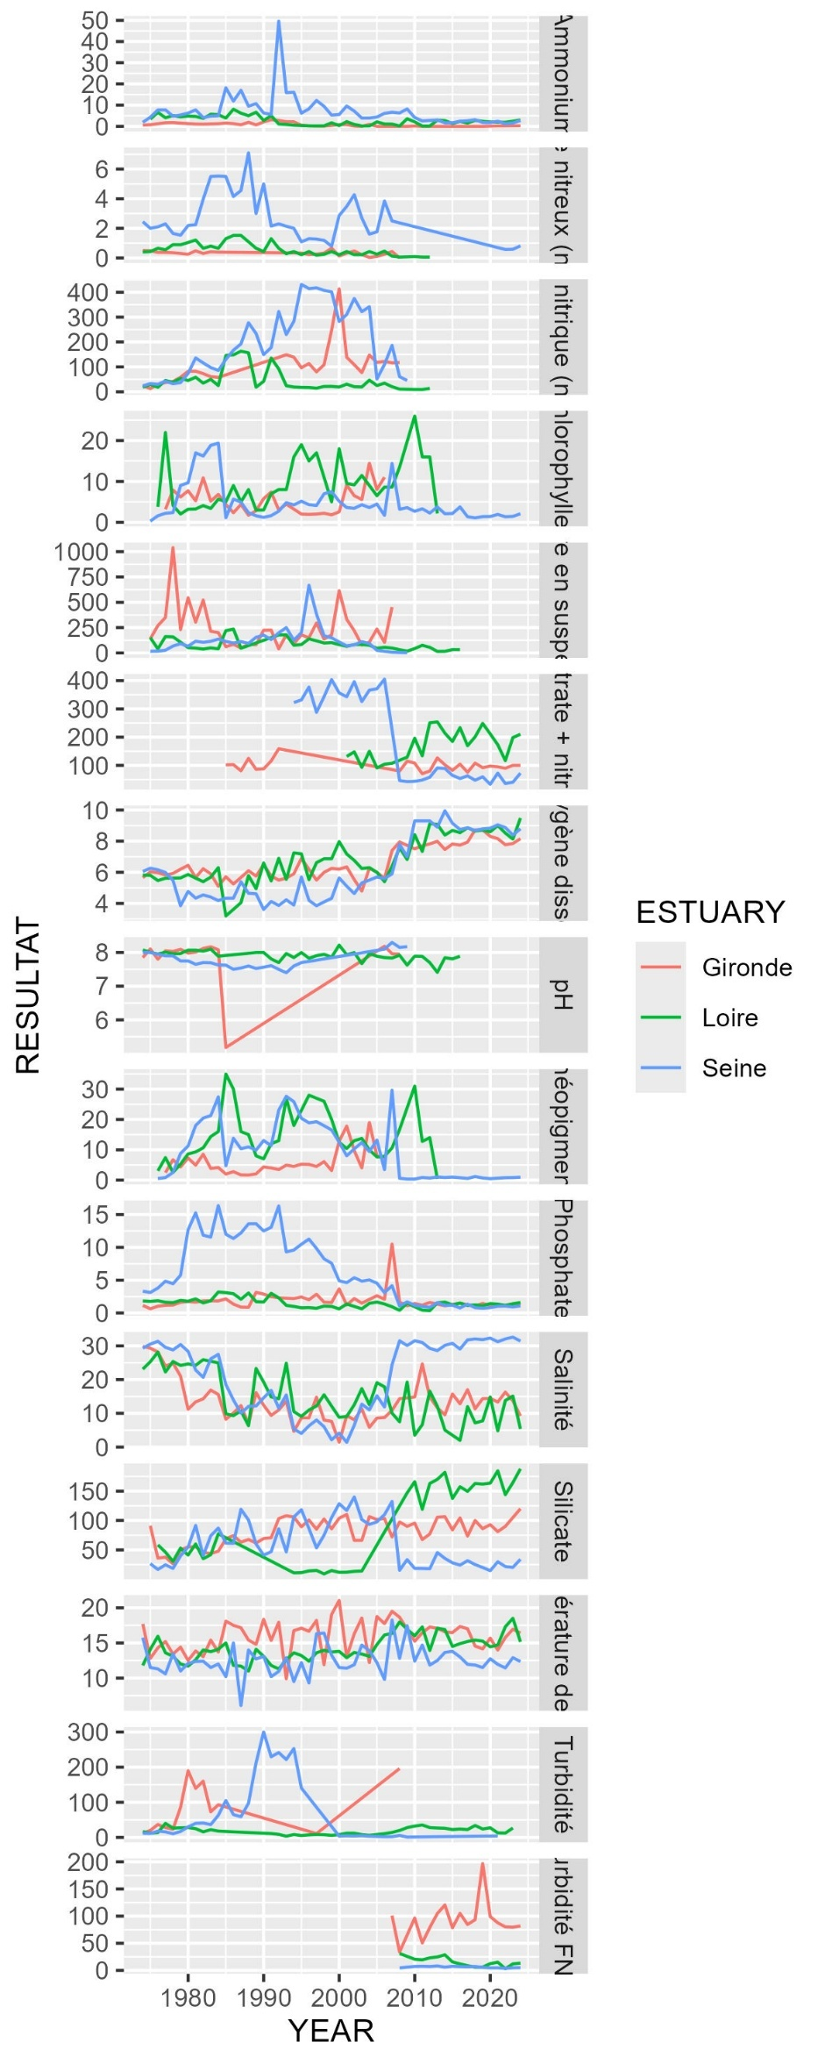

#### PCA

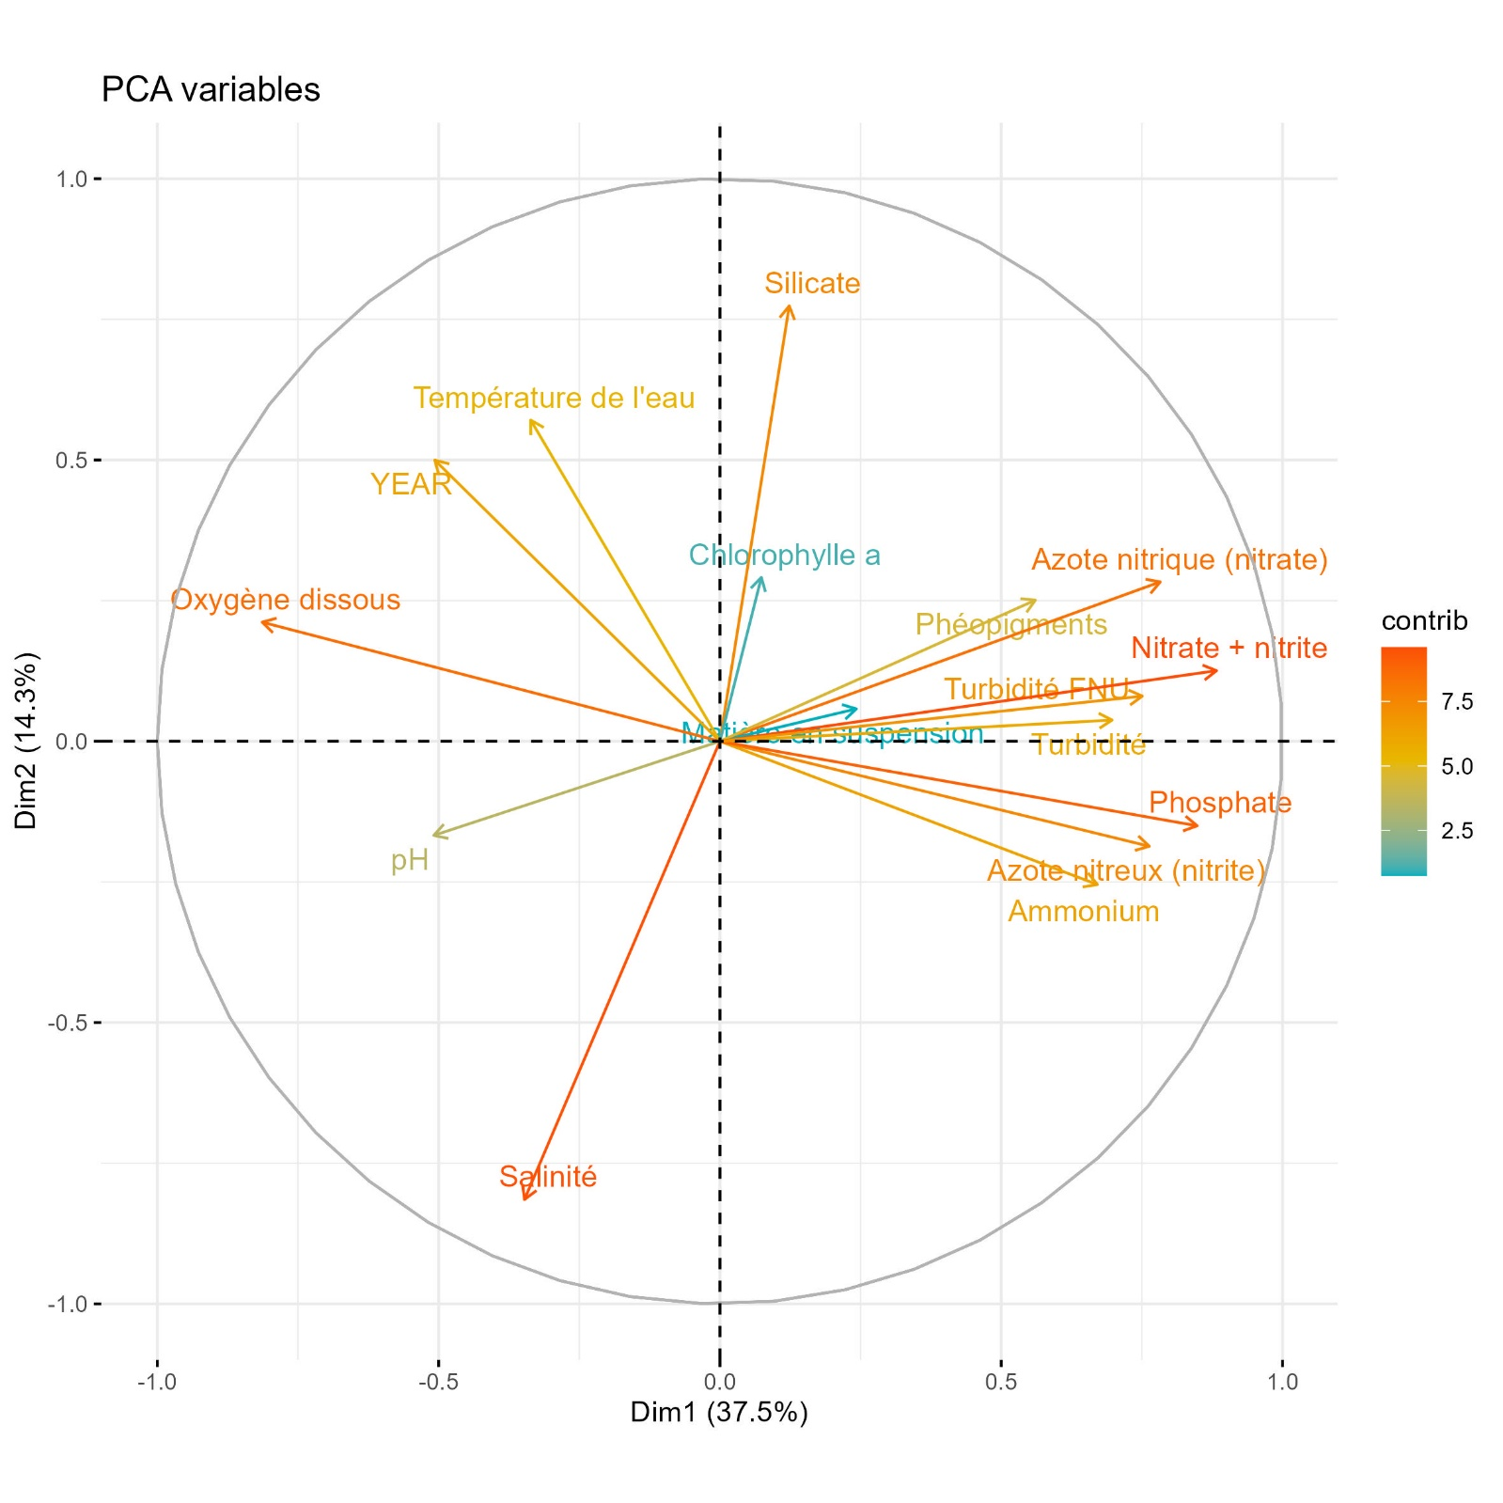

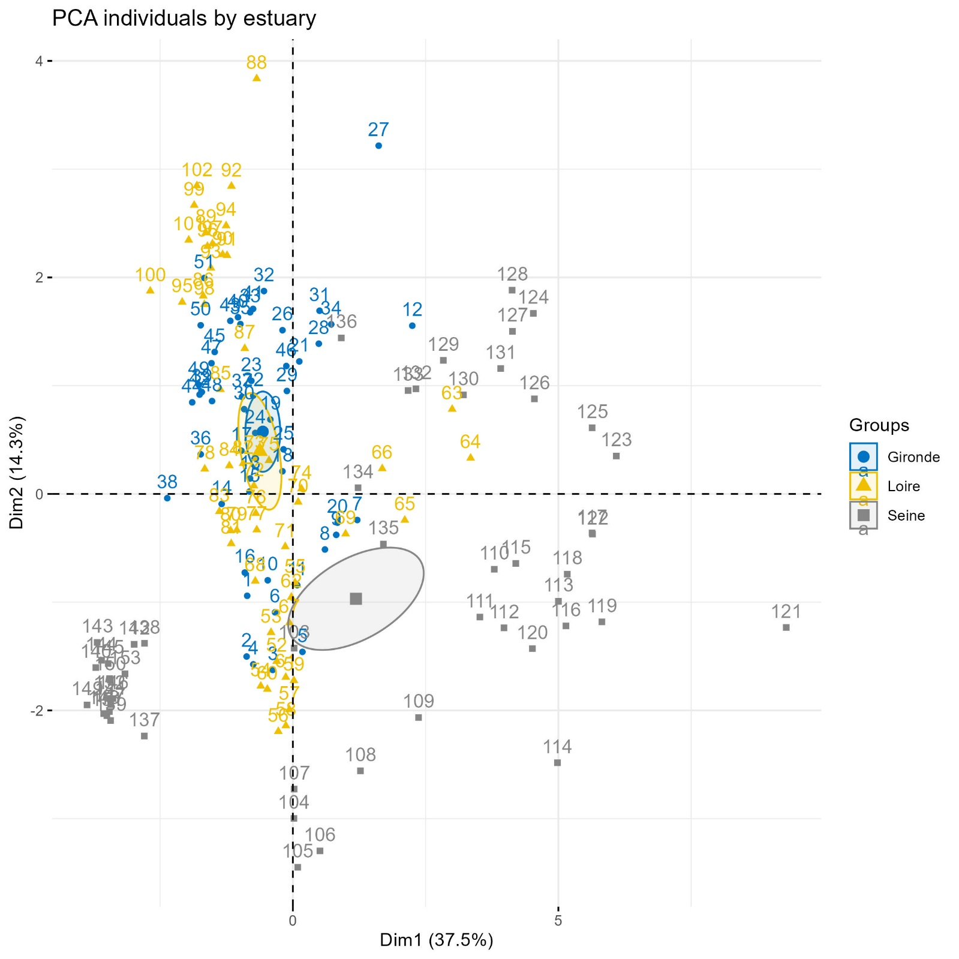

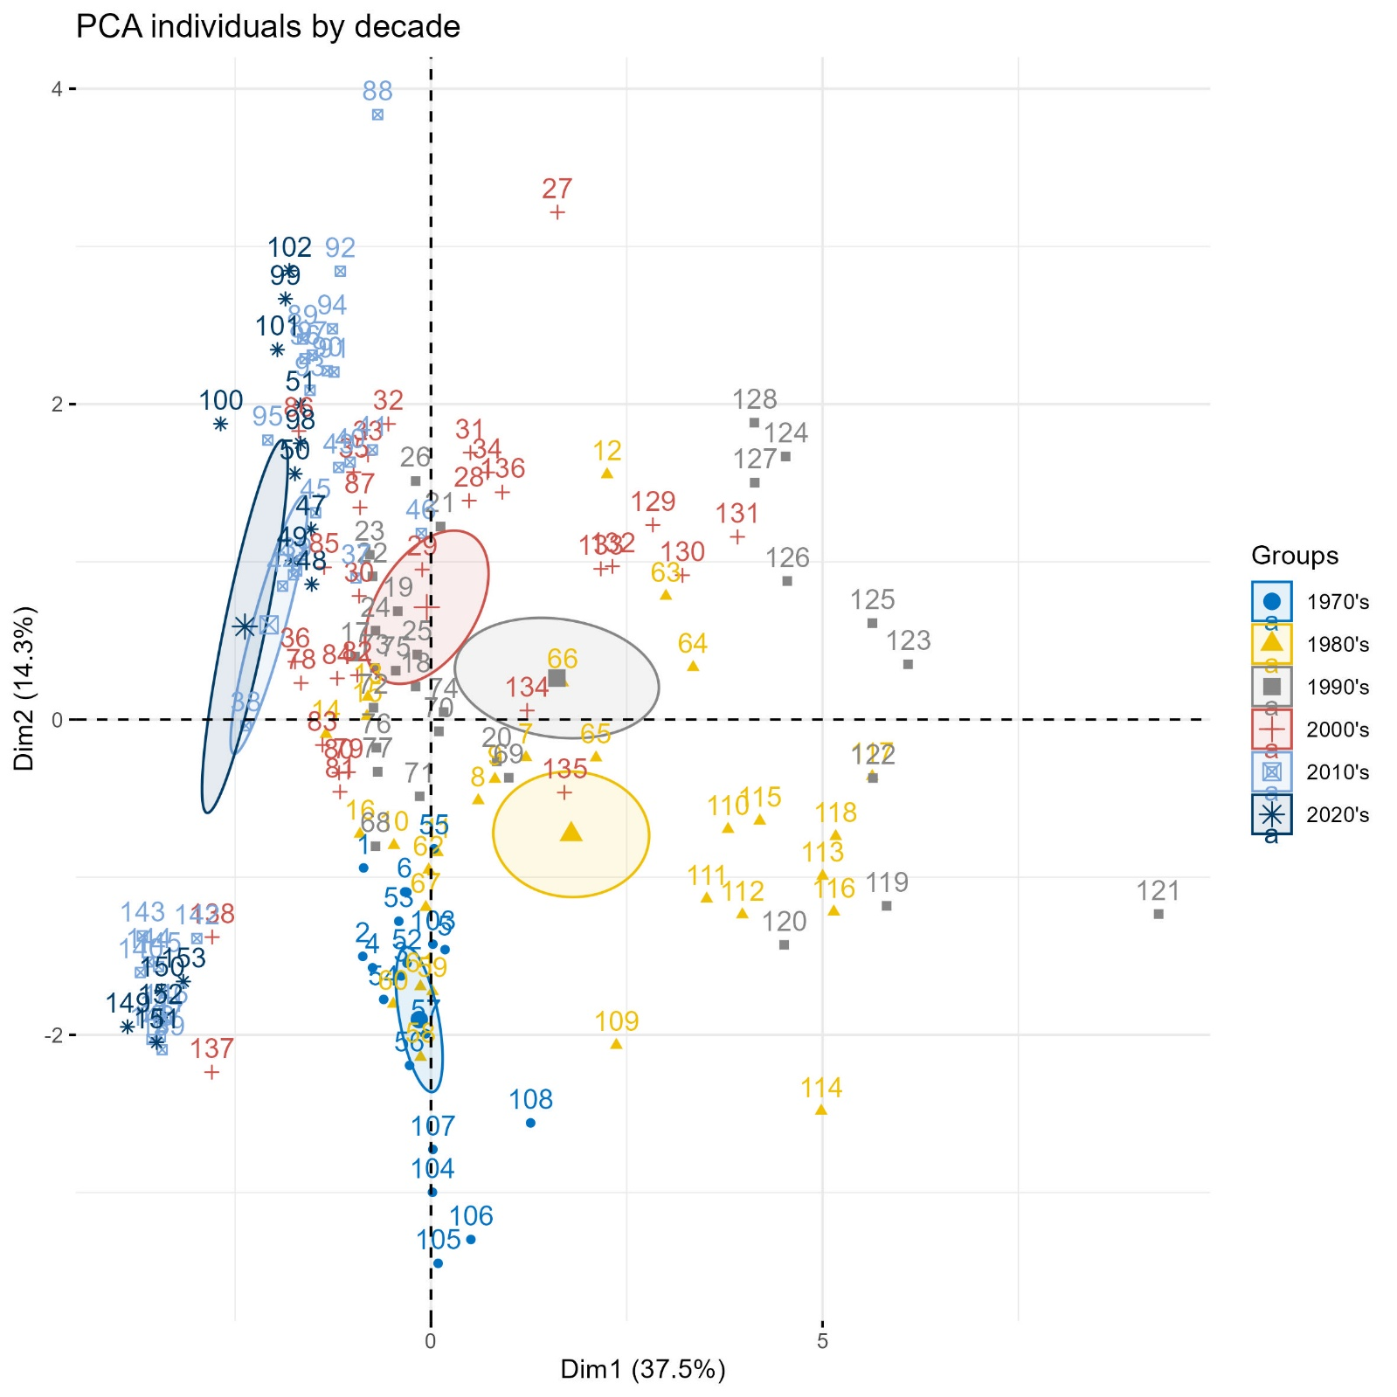

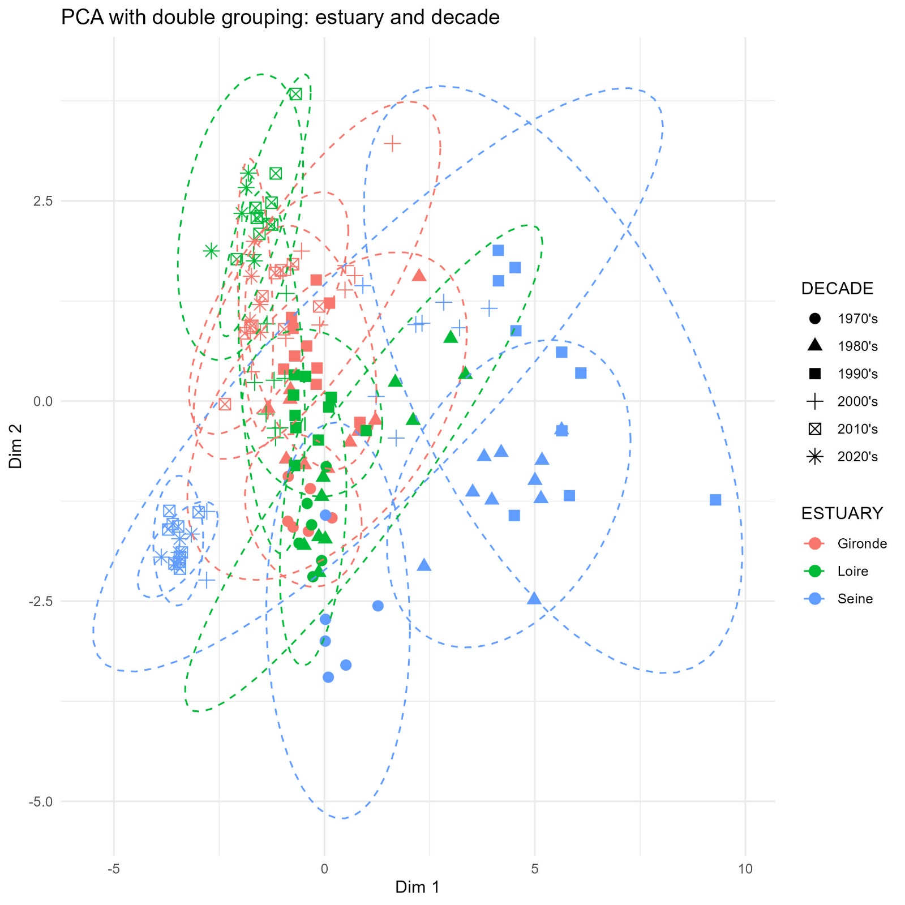

## Results

### Contamination

#### Metals

|  |  |
| --- | --- |
|  |  |
| Figure 2 – Time series of metal contamination in the Gironde, Loire and Seine estuaries from 1979 to 2024. Arrows indicate trends over the most recent 15-year period (Spearman’s rank correlation test). Dashed horizontal lines represent current sanitary thresholds, where applicable. | Figure 3 – Long term evolution of metal contamination in the Gironde, Loire and Seine estuaries, expressed as percentage deviation from current sanitary thresholds, where applicable. Comparisons are made between the periods 1979–1983 (First period) and 2020–2024 (Last period). Arrows indicate long-term trends (Kruskal-Wallis rank sum test). |

Time series data on metal contamination from 1979 to 2024 indicate that, across all estuaries, mercury consistently remains the least detected contaminant during the 2020-2024 period, with a median concentration of 0.025 µg/gww. This is followed by cadmium (0.230 µg/gww), lead (0.249 µg/gww), and copper (2.069 µg/gww).

Contaminant levels for each metal remain below the established sanitary thresholds (OSPAR, 2023a) across all estuaries, with the exception of cadmium in the Gironde estuary, where concentrations exceed the threshold by a factor 2.5. Overall, the Gironde estuary exhibits the highest metal contamination, while the Seine estuary is the least contaminated.

Historical data reveal that the Gironde estuary has consistently been more contaminated than the other, particularly with cadmium and copper. Between 1979 and 1983, cadmium and copper concentrations in the Gironde were approximately 28-fold and 3-fold higher, respectively, compared to the Loire estuary, which exhibited the lowest levels during that period. A long-term comparison between the first and last five years of monitoring (1979–1983 vs. 2020–2024) shows a significant decline in cadmium concentrations across all estuaries. In the Gironde estuary, cadmium concentrations decreased from 7.7 to 2.4 µg/gww. However, current levels remain above the sanitary threshold (1 µg/gww) and those observed in the Loire (0.2 µg/gww) and Seine (0.3 µg/gww) estuaries. Over the past 15 years, cadmium concentrations have continued to decline across all estuaries, although the decrease is not statistically significant for the Seine and Gironde estuaries.

For copper, the concentration gap between the Gironde and the other estuaries has widened over time, driven by a significant long-term increase in the Gironde, while concentrations in the other estuaries have remained stable. Thought, recent trends indicate rising copper levels in all estuaries, with a significant increase observed in the Loire.

No significant long-term or recent trends were detected for mercury concentrations in any estuary.

Lead concentrations show a significant long-term and recent decline in the Loire estuary. No significant trends were identified in the other estuaries, however, results indicate a decreasing trend in the Seine estuary and an increasing trend in the Gironde estuary.

#### Polycyclic aromatic hydrocarbon (PAH)

|  |  |
| --- | --- |
| Figure 6 – Time series of PAH compounds contamination in the Gironde, Loire and Seine estuaries from 1994 to 2024. Arrows indicate trends over the most recent 15-year period (Spearman’s rank correlation test). Dashed horizontal lines represent current ecotoxicological thresholds. | Figure 7 – Long term evolution of PAH compounds contamination in the Gironde, Loire and Seine estuaries, expressed as percentage deviation from current ecotoxicological thresholds. Comparisons are made between the periods 1994–1998 (First period) and 2020–2024 (Last period). Arrows indicate long-term trends (Kruskal-Wallis rank sum test). |

Time-series data show that contamination levels of all PAH compounds remain below their respective OSPAR ecotoxicological thresholds across all estuaries. Among them, the Seine estuary exhibits the highest PAH concentrations, while the Loire and Gironde estuaries show similar and comparatively lower levels.

Most long-term and recent trends indicate decreasing concentrations across estuaries, whether statistically significant or not. An exception is observed for benzo(ghi)perylene in the Gironde estuary, where a slight increase is recorded. The long term increase corresponds to a +2% deviation from the threshold and is statistically significant in the recent trend (Spearman’s ρ = 0.76, p.value = 0.002).

#### Organochlorine pesticides

|  |  |
| --- | --- |
| Figure 4 – Time series of OC pesticides contamination in the Gironde, Loire and Seine estuaries from 1982 for lindane (gamma-HCH) and 1979 for DDT to 2023. Arrows indicate trends over the most recent 15-year period (Spearman’s rank correlation test). Dashed horizontal lines represent current ecotoxicological thresholds. | Figure 5 – Long term evolution of PCBi contamination in the Gironde, Loire and Seine estuaries, expressed as percentage deviation from current ecotoxicological thresholds. Comparisons are made between the periods 1982–1986 (First period for lindane) or 1979-1983 (First period for DDT) and 2019–2023 (Last period). Arrows indicate long-term trends (Kruskal-Wallis rank sum test). |

Long-term trends show a significant decrease in concentrations of both OC pesticides across all estuaries.

Although γ-HCH exceeded its ecotoxicological threshold during the initial years of monitoring, its concentrations have declined markedly and it has not been detected in approximately the past ten years.

Recent trends for the sum of DDT-related compounds indicate a significant decrease in the Loire and Seine estuaries, while non-significant increase was observed in the Gironde estuary. Currently, DDT concentrations are below the ecotoxicological threshold in all estuaries, at less than 2% of the threshold value.

#### PCB indicators

|  |  |
| --- | --- |
| Figure 8 – Time series of PCBi contamination in the Gironde, Loire and Seine estuaries from 1988 to 2024. Arrows indicate trends over the most recent 15-year period (Spearman’s rank correlation test). Dashed horizontal lines represent current ecotoxicological thresholds. | Figure 9 – Long term evolution of PCBi contamination in the Gironde, Loire and Seine estuaries, expressed as percentage deviation from current ecotoxicological thresholds. Comparisons are made between the periods 1988–1992 (First period) and 2020–2024 (Last period). Arrows indicate long-term trends (Kruskal-Wallis rank sum test). |

Time series data on PCB indicators (PCBi) contamination from 1988 to 2024 indicate a generally significant lon-term decline in concentrations for all congeners across the three estuaries. In contrast, recent trends over the past 15 years show mostly non-significant changes in contamination levels, with the exception of CB 52 and CB 118 in the Seine estuary, for which slightly significant decreasing trends were observed (p-value = 0.044 and 0.048, for CB 52 and CB 118, respectively). By comparing concentrations from the first and last years of the 32-year monitoring period to estimate a linear rate of decline, it is possible to project the time required for CB 118 concentrations to fall below the EQS. Based on these estimates, concentrations are expected to reach compliant levels in approximately 6 years in the Seine estuary.

The Seine estuary consistently exhibits higher levels of contamination compared to the other estuaries, with congener-specific differences ranging from a 2.5-fold increase for CB153 to a 9-fold increase for CB118. The Gironde and the Loire estuaries display comparable PCBi contamination levels, except for CB 153 and CB180, for which concentrations in the Gironde approach those observed in the Seine.

In 2024, the most recent monitoring year, all estuaries reported concentrations below the OSPAR legislative thresholds for PCB congeners with both the lowest (CB 28,CB 152) and highest (CB 153, CB 180) hydrophobicity levels (Hawker et Connell, 1988). In contrast, congeners with intermediate hydrophobicity, associated with the highest bioaccumulation potential, exceed threshold in the Seine estuary (CB 101 and CB138), and in the case of CB 118 (a dioxine-like congeners with higher toxicity), in all estuaries.

#### Dioxins and dioxin-like compounds

|  |  |
| --- | --- |
| Figure 10 – Time series of summed dioxins and dioxin-like compound contamination in the Gironde, Loire and Seine estuaries from 2008 to 2024. Arrows indicate trends over the full monitoring period (Spearman’s rank correlation test). Dashed horizontal lines represent current sanitary thresholds. | Figure 11 – Percentage of deviation from current sanitary threshold in the Gironde, Loire and Seine estuaries over the full monitoring period for the sum of dioxins and dioxin-like compound contamination. |

The sum of dioxins and dioxin-like compound concentrations is highest in the Seine estuary, with levels approximately six times higher than those in the Loire estuary and sixteen times higher than those in the Gironde. The median concentration in the Seine estuary over the entire monitoring period is 2.7 times greater than the sanitary threshold established by the European Commission. Occasional peak values in both the Gironde and Loire estuaries also exceeded this threshold in specific years.

Over the full monitoring period, an increasing trend in dioxins and dioxin-like compound concentrations was observed in all estuaries, with a statistically significant increase in the Loire estuary. In the Seine estuary, however, the trend is more complex, showing a marked increase before 2015 followed by a modest decline thereafter.

#### Brominated flame retardant

|  |  |
| --- | --- |
| Figure 12 – Time series of brominated flame retardants contamination in the Gironde, Loire and Seine estuaries from 2008 and 2018 to 2024. Arrows indicate trends over the full monitoring period (Spearman’s rank correlation test). Dashed horizontal lines represent current sanitary thresholds. | Figure 13 – Percentage of deviation from current ecotoxicological threshold in the Gironde, Loire and Seine estuaries over the full monitoring period for the brominated flame retardants contamination. |

All HBCDD isomers are present at low concentrations across the estuaries, remaining well below the European Commission Environmental Quality Standard (EQS) for fish, with deviations of less than 0.1%. Trends are generally stable or decreasing in all estuaries. An exception is observed for β-HBCDD in the Loire estuary, where a statistically significant increase is detected (Spearman’s ρ = 0.90, p.value = 0.006).

In contrast, summed PBDE concentrations exceed the European EQS by a large margin, with deviations of 906% in the Gironde estuary, 1058% in the Loire, and 3904% in the Seine. However, by comparing concentrations from the first and last years of the 16-year monitoring period to estimate a linear rate of decline, it is possible to project the time required for concentrations to fall below the EQS. Based on these estimates, concentrations are expected to reach compliant levels in approximately 1.2 years in the Gironde, 3.7 years in the Loire, and 3.2 years in the Seine estuary.

#### Perfluorinated compound: PFOS

|  |  |
| --- | --- |
| Figure 14 – Time series of PFOS contamination in the Gironde, Loire and Seine estuaries from 2010 to 2024. Arrows indicate trends over the full monitoring period (Spearman’s rank correlation test). Dashed horizontal lines represent current sanitary thresholds. | Figure 15 – Percentage of deviation from current ecotoxicological threshold in the Gironde, Loire and Seine estuaries over the full monitoring period for PFOS contamination. |

PFOS is an emerging contaminant that has been monitored since 2010 under the ROCCHMV program. Concentration levels remain well below the European EQS for fish, with median values showing less than 2.5% deviation from the EQS across all estuaries. No significant trends have been identified over this relatively short monitoring period. Although a slightly statistically significant decrease was observed in the Seine estuary (Spearman’s p = -0.56, p.value = 0.049), the magnitude of the decline is minimal and not considered environmentally meaningful.

#### Tributyltin cation

|  |  |
| --- | --- |
| Figure 16 – Time series of tributyltin cation contamination in the Gironde, Loire and Seine estuaries from 2019 to 2024. Arrows indicate trends over the full monitoring period (Spearman’s rank correlation test). Dashed horizontal lines represent current sanitary thresholds. | Figure 17 – Percentage of deviation from current ecotoxicological threshold in the Gironde, Loire and Seine estuaries over the full monitoring period for tributyltin cation contamination. |

Tributyltin cation is an emerging contaminant that has been monitored since 2019 under the ROCCHMV program. Due to the limited duration of the time series, no significant trends have been identified. The Gironde estuary is the least contaminated, with median concentrations corresponding to 16% of the OSPAR ecotoxicological threshold. In contrast, concentrations in the Seine and Loire estuaries occasionally exceed the threshold, with peak values reaching up to twice the threshold in the Loire. Still, median values remain below the threshold, corresponding to 55% in the Loire and 78% in the Seine. However, given the short duration of monitoring, no definitive conclusions can yet be drawn.

#### Emerging biocides

Table 5 – Emerging biocides studied in the Gironde, Loire and Seine estuaries under the Emergent’Sea research program along with their PNEC (in μg/kg_ww for biota, in μg/L for POCIS) values. Colors correspond to deviation from PNEC value (blue: [0-100%[, yellow:[100-200%[, orange: [200-300%[, red: [300-400%[, black: > 400%). The position indicates the degree of priorisation of the substance defined by the Emergent’Sea program.

|  |  |  |  |  |  |  |  |  |  |  |  |
| --- | --- | --- | --- | --- | --- | --- | --- | --- | --- | --- | --- |
|  |  |  |  | Gironde | | | Loire | | | Seine | |
| Family | Compound | PNEC | Position | % France | % PNEC | % France | | % PNEC | % France | | % PNEC |
| Antifouling | Copper pyrithione | **-** | **-** |  | NA |  | | NA |  | | NA |
| DCOIT | **0.07** | **18** |  |  |  | |  |  | |  |
| Dichlofluanide | **0.03** | **6** |  |  |  | |  |  | | > PNEC |
| Irgarol | **0.01** | **23** |  | > PNEC |  | |  |  | |  |
| Medetomidine | **0.00** | **12** |  |  |  | |  |  | |  |
| Tralopyril | **0.68** | **17** |  |  |  | |  |  | |  |
| Zinc pytithione | **-** | **-** |  | NA |  | | NA |  | | NA |
| Fungicide | Azoxystrobin | **0.06** | **3** |  |  |  | |  |  | | > PNEC |
| Boscalid | **232.95** | **22** |  |  |  | |  |  | |  |
| Chlorothalonil | **0.06** | **9** |  |  |  | |  |  | |  |
| Epoxiconazole | **-** | **-** |  | NA |  | | NA |  | | NA |
| Propiconazole | **1.60** | **19** |  |  |  | |  |  | |  |
| Thirame | **0.04** | **10** |  | > PNEC |  | |  |  | | > PNEC |
| Tebuconazole | **1.46** | **4** |  |  |  | |  |  | |  |
| Herbicide | *AMPA (POCIS)* | ***150*** | ***33*** |  |  |  | |  |  | |  |
| *Glyphosate (POCIS)* | ***12*** | ***20*** |  |  |  | |  |  | |  |
| 3,4-DCA | **0.06** | **11** |  |  |  | | > PNEC |  | | > PNEC |
| Chlorprophame | **3.24** | **31** |  |  |  | |  |  | |  |
| Chlortoluron | **0.54** | **21** |  |  |  | |  |  | |  |
| DCPMU | **0.88** | **13** |  |  |  | |  |  | |  |
| DCPU | **2.30** | **20** |  |  |  | |  |  | |  |
| DEA (Atrazine desethyl) | **0.07** | **25** |  |  |  | |  |  | |  |
| Diflufenican | **0.01** | **1** |  | > PNEC |  | | > PNEC |  | | > PNEC |
| Dimethenamide | **0.20** | **29** |  |  |  | |  |  | |  |
| Diuron | **0.71** | **26** |  |  |  | |  |  | |  |
| Linuron | **0.04** | **5** |  | > PNEC |  | | > PNEC |  | |  |
| Metoxuron | **0.10** | **27** |  |  |  | |  |  | |  |
| Metolachlor | **0.27** | **7** |  |  |  | |  |  | |  |
| Propazine | **0.06** | **24** |  |  |  | |  |  | |  |
| Terbuthylazine desethyl | **0.07** | **15** |  |  |  | |  |  | |  |
| Insecticide | Fipronil | **0.00** | **2** |  | > PNEC |  | | > PNEC |  | | > PNEC |

Among the 31 emergent biocides assessed, eight exceeded their respective PNEC in at least one estuary. Two compounds, diflufenican and fipronil, exceeded the PNEC by more than a factor of four in all three estuaries. These substances are ranked first and second in the Emergent’Sea program’s monitoring prioritization. The fact that fipronil and diflufenican are not systematically detected at higher concentrations in estuaries compared to the national average suggests that PNEC exceedances are also frequent along other parts of the French coastline, justifying their high prioritization.

Among herbicides, in addition to diflufenican, linuron and 3,4-dichloroaniline (3,4-DCA) were notably detected in the Loire and Gironde estuary, respectively, and are also highly prioritized for monitoring. Some other herbicides were found at elevated levels in only one estuary but remained below their PNEC values and were assigned a lower monitoring priority.

For antifouling agents, particularly marked results were observed. Dichlofluanide was found at concentrations exceeding its PNEC in the Seine estuary, while being negligible in other estuaries. Similarly, irgarol was found at elevated levels in the Gironde estuary, although it was not highly prioritized in the national monitoring framework.

Among fungicides, azoxystrobin ranked highest in monitoring prioritization and exceeded its PNEC in the Seine estuary. Tebuconazole also received a high priority ranking and was found at the highest concentrations in the Gironde and Loire estuaries, although levels remained below the PNEC. Thiram exceeded its PNEC in both the Gironde and Seine estuaries.

Overall, the Seine estuary showed the highest number of compounds exceeding PNEC values (n = 6), while the Gironde estuary exhibited the highest exceedance levels for all compounds concerned (n = 5).

### Benthic macrofauna

#### Campaign

|  |  |
| --- | --- |
|  |  |
|  | |

#### Taxonomic composition

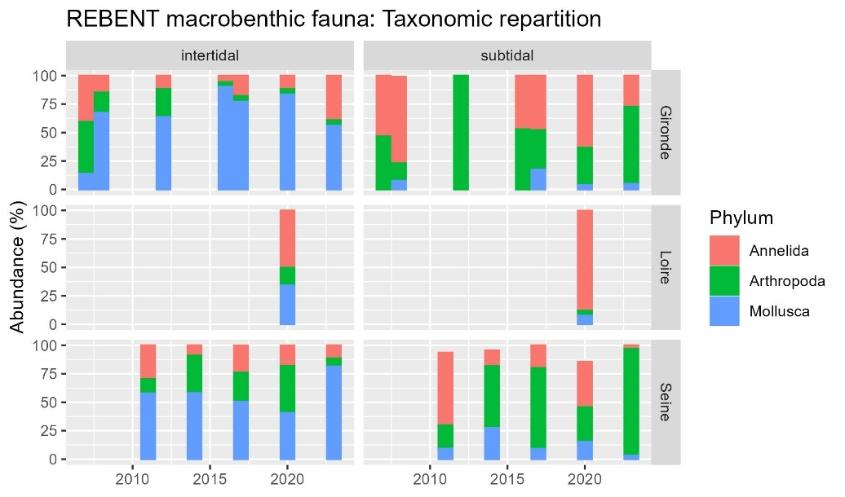

* Intertidal: highest abundance for mollusks for Gironde and Seine, annelids in Loire (Cordemay amphipods ++ since 2020)
* Subtidal: highest abundance of arthropods than annelids, for Gironde and Seine, annelids in Loire

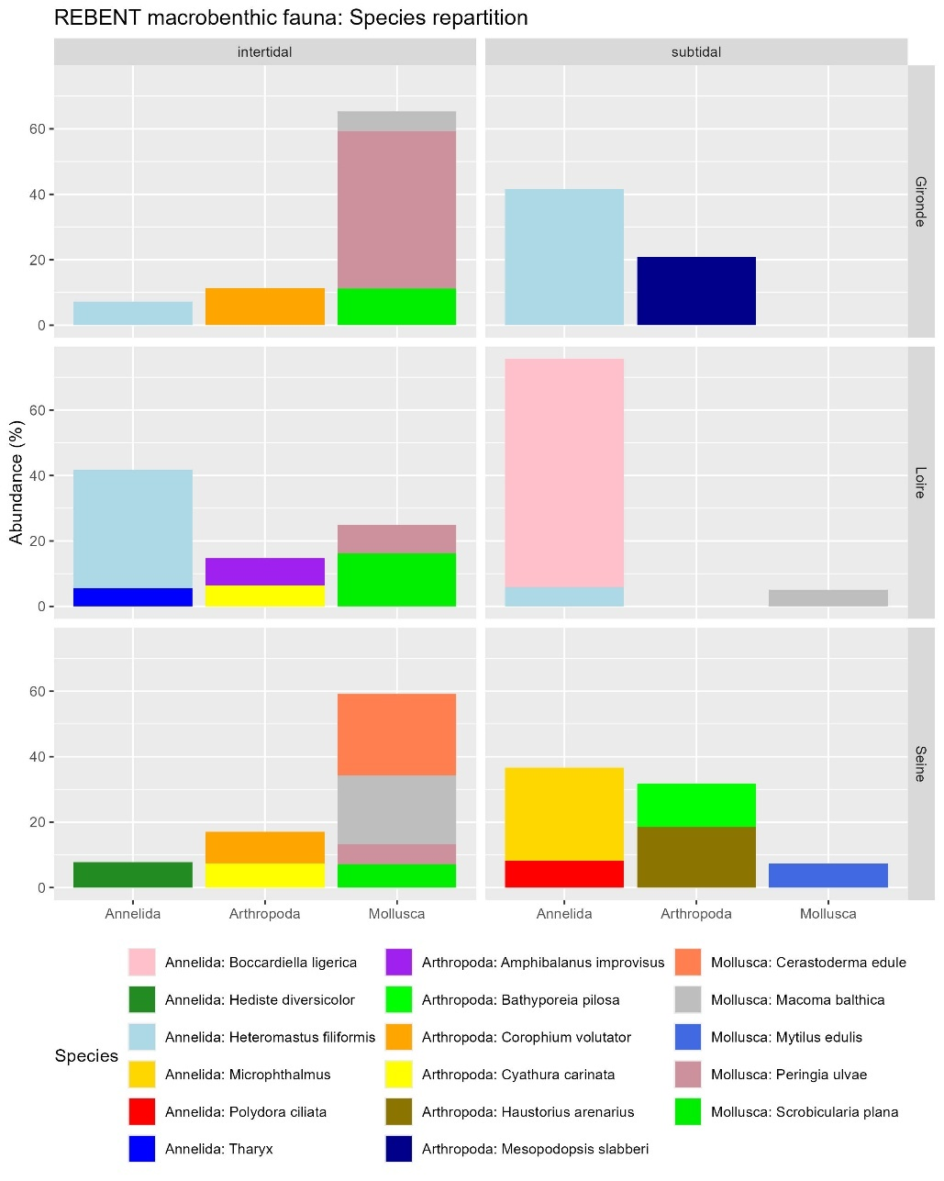

#### Abundance / Density

|  |  |
| --- | --- |
|  | * Much higher in intertidal areas than in subtidal areas * 3 fold higher in Loire intertidal areas than the highest densities in other estuaries and areas. * Seems to increase in both areas of the Seine and the Gironde estuary since 2007 |

#### BEQI-Fr index: general quality / disturbances sensitivity

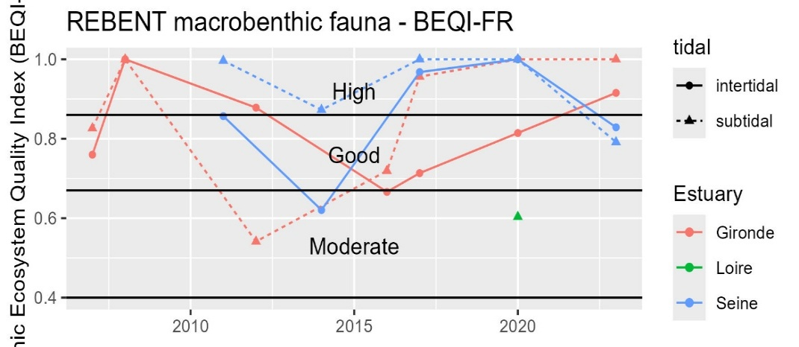

### Fish and demerso-pelagic preys

### Physico-chemical parameters

#### Primary production: pheopigment / chlorophyl a

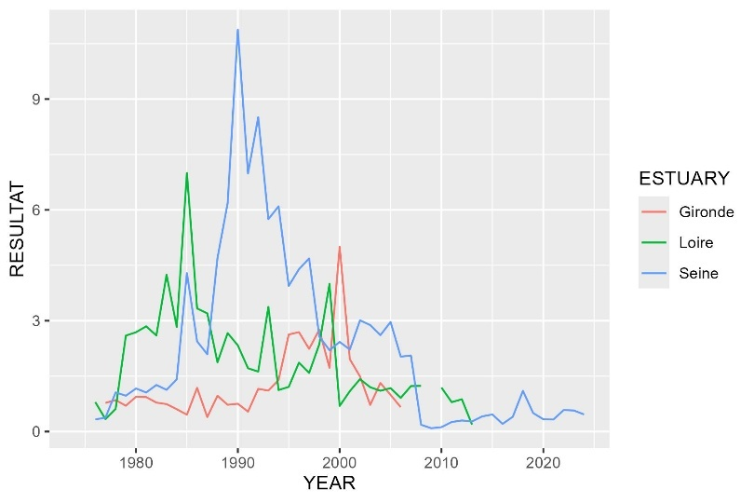

#### Nitrification cycle: Ammonium / nitrate+nitrite

|  |  |
| --- | --- |
|  | La somme calculée en Loire semble plus forte que celle mesurée dans Quadrige   * On garde quand même ? |
|  | * Reconstruction de la somme nitrate+nitrite à partir de la valeur max de « Nitrate + nitrite » ou « sumNO2NO3 » * Indicateur = Ammonium / (N02+NO3) * Ratio < 0.1 🡪 bonne nitrification * Ratio entre 0.1 et 1 🡪 conditions intermédiaires, dysfonctionnement saisonnier possible du cycle avec accumulation d’ammonium pouvant indiquer hypoxie, pollution organique, altération microbiologique |

## Discussion

### Contamination

#### Metals

Overall, metal concentrations remain at levels considered safe and exhibit either stable or decreasing recent trends. However, the Gironde estuary stands out as potentially impacted by elevated cadmium and copper concentrations, which are significantly higher than those observed in the other estuaries, with potential adverse effects affecting phytoplankton (Hindarti et Larasati, 2019) to invertebrates and fish (Wright et Welbourn, 1994). This historical metal contamination originates from metallurgical activities, including discharges from industrial sites and erosion of metalliferous deposits within the watershed (Sautour et Baron, 2020).

Although cadmium levels declined significantly between approximately 1990 and 2000, following the cessation of zinc metallurgy in Aveyron and the containment of associated waste, no further decrease has been observed in the Gironde estuary over the past two decades. As of 2024, cadmium concentrations remain above the sanitary threshold for shellfish consumption. This persistent contamination is linked to the sedimentary reservoir within the watershed and estuary, which continues to release metals during major hydrodynamic events such as floods (Sautour et Baron, 2020). In addition, current sources of cadmium include the application of phosphate fertilizers and the spreading of urban sewage sludge on agricultural land (Sautour et Baron, 2020). Given these factors, cadmium levels in the Gironde estuary are unlikely to fall below the sanitary threshold within the next decade.

Regarding copper, its long-term increase in the Gironde estuary and recent rise in the Loire estuary may be attributed to both historical and ongoing agricultural practices. In particular, copper sulfate (Bordeaux mixture), used as a fungicide in vineyards and orchards—including in organic farming—is readily mobilized by runoff and erosion, contributing to estuarine contamination (Blanc, 2025).

#### Organochlorine compounds

Across organochlorine pesticides, PCBs, and dioxins and dioxin-like compounds, the Seine estuary exhibits the highest levels of contamination, with particularly elevated concentrations of PCBs and dioxin-like compounds, both of which are known for their high toxicity and persistence in aquatic environments (Walker et Peterson, 1994).

In contrast, concentrations of organochlorine pesticides are reassuringly low, currently below ecotoxicological thresholds, generally decreasing, and approaching detection limits, even in the Seine estuary. This decline is consistent with regulatory measures, including the prohibition of lindane (γ-HCH) production and use in the European Union since 2007, and the ban on DDT in agricultural applications since 1970 (Ifremer, 2025).

For PCBs, time series data indicate a long-term decline in contamination levels, consistent with regulatory actions implemented in France since 1987. A decree issued in February 2003, in accordance with a 1996 European directive, mandated the elimination of all equipment containing PCBs by the end of 2010. The Stockholm Convention further calls for their complete phase-out by 2025 (Ifremer, 2025). Despite these measures, concentrations remain above ecotoxicological thresholds in all the estuaries for CB 118, a dioxin-like congener with high toxicity. In the Seine estuary, exceedances are observed for all congeners except CB28 and CB180. Notably, in the Seine, the degree of threshold exceedance appears to be correlated with the bioaccumulation potential of the congeners. This potential can be approximated by physicochemical properties such as log Kow. Studies have shown a parabolic relationship between bioaccumulation/biomagnification and log Kow values, with accumulation increasing up to a log Kow of approximately 6.5–7, then declining beyond this range (Fisk *et al.*, 1998; Borgå *et al.*, 2004). This is consistent with the limited threshold exceedance observed for CB 28 (log Kow = 5.67) and CB 180 (log Kow = 7.36) (Hawker et Connell, 1988).

Although recent trends for most PCB congeners are decreasing, these declines are generally not statistically significant. For CB 118 in the Seine estuary, levels are projected to fall below the OSPAR threshold within approximately six years. This prolonged decline, despite regulatory measures since 1987, reflects the high environmental persistence characteristic of this compound family.

With regard to dioxins and dioxin-like compounds, concentrations in the Seine estuary have consistently exceeded the human health threshold since monitoring began in 2008 under the ROCCHMV program, despite a recent downward trend. Threshold exceedances have also been observed sporadically in the Gironde and Loire estuaries. However, the high interannual variability in these two systems limits the ability to clearly determine long-term trends. Indeed, this contamination pattern likely reflects the unintentional nature of dioxin and dioxin-like compound production and release, as they are by-products of combustion processes and certain industrial activities. Consequently, although these compounds are of particular ecotoxicological concern—being listed as Persistent Organic Pollutants (POPs) under the Stockholm Convention and classified as priority hazardous substances by the European Union (Directive 2013/39/EU, 2013)—their presence in the environment cannot be directly reduced through bans or phase-out measures, as is possible for intentionally produced substances.

#### PBDE

As for the organochlorine compounds, the Seine estuary is the highest contaminated estuary in PBDE. However, PBDE levels exceeded EQS for fish matrix (European Commission, 2013) for all of the estuaries. Given their poor biomagnification potential (Kelly *et al.*, 2008), it is possible that the corresponding threshold in bivalves matrix may be lower than the one defined in fish matrix. However, reported contamination of the sum of PBDE in ng/glw in biota in a Canadian Arctic marine food web indicated a factor 2 to 14 between the blue mussel *Mytilus edulis* and four fish species (Kelly *et al.*, 2008). As the threshold is exceed by a factor 9 for the Gironde, 10 for the Loire and 39 for the Seine estuary, we can conclude that EQS would be exceeded in bivalve matrix, at least in the Seine estuary.

Global production of PBDEs increased exponentially beginning in the 1980s. In Europe, the use of penta- and octa-brominated technical mixtures was banned in August 2004, followed by their global restriction under the Stockholm Convention in May 2009. PBDEs are no longer produced in France or in the European Union (Ifremer, 2025). As PBDEs have only been monitored since 2008 under the ROCCHMV program, long-term trends cannot be assessed. However, recent data indicate a statistically significant decrease in concentrations, with levels projected to fall below the European EQS within approximately 1.2 to 3.7 years, depending on the estuary. This pattern suggests that, despite their low degradability and high lipophilicity—traits underlying their classification as Persistent Organic Pollutants (POPs), similar to PCBs—their relatively low biomagnification potential may contribute to a more rapid decline in bivalve tissues compared to PCBs.

#### Biocides

For the sake of concision, the results presented in this study are based on mean concentrations from three sampling periods (February, June, and November) for some compounds (i.e., AMPA and glyphosate). However, data from the Emergent’Sea program reveal substantial seasonal variability in contamination profiles, with higher pesticides concentrations often observed in February and November. Consequently, the use of mean values may underestimate peak contamination events and, in turn, the potential exceedance of PNEC values for these compounds.

Diflufenican, an herbicide detected at high concentration across all estuaries, is ranked as the top-priority compound for future monitoring according to the Emergent’Sea program. It has been show to adversely affect phytoplankton (Martínez-Gómez *et al.*, 2009), potentially disrupting the entire trophic web that depends on these primary producers. Similar concerns apply to 3,4-dichloroaniline (3,4-DCA), which exceeds its PNEC in the Loire and Seine estuaries, and linuron, which exceeds the PNEC in the Gironde and Loire estuaries. Notably, 3,4-DCA is a degradation product of several herbicides, formed through microbial activity, and is more persistent than its parent compounds. In addition to their phytotoxicity, diflufenican, linuron and 3,4-DCA are highly toxic to aquatic organisms, including mysids (Sardo *et al.*, 2005) and fish larvae (Soloperto *et al.*, 2022), with broader impacts on aquatic fauna also documented (Rebelo, Antunes et Rodrigues, 2023). Other herbicides are also known to negatively affect aquatic organisms (Lebrun *et al.*, 2022). The distinct contamination profiles observed in each estuary likely reflect variations in historical and current agricultural practices within their respective catchment areas. For instance, the widespread use of glyphosate in cereal cultivation in the Seine watershed may account for the presence of both glyphosate and its primary metabolite, AMPA, in that estuary.

Fipronil, the second-highest ranked compound in the Emergent’Sea prioritization, is an insecticide that exceeds its PNEC in all three estuaries. It is known to negatively affect crustaceans in estuarine environments (Hano *et al.*, 2022), potentially reducing the availability of prey for juvenile fish.

Tributyltin (TBT), a legacy antifouling biocide extensively used since the 1960s, is still detected in some estuaries despite its ban on small vessels in France since 1982 and global prohibition in 2008 (Martins *et al.*, 2018). Its impacts on marine organisms, particularly gastropods and oysters, are well documented (Martins *et al.*, 2018; Luo *et al.*, 2023). The elevated concentrations occasionally observed in the Seine and Loire estuaries may reflect remobilization from contaminated sediments (Luo *et al.*, 2023)

Following the ban on TBT, several alternative antifouling biocides were introduced. Among them, dichlofluanid in the Seine estuary and irgarol in the Gironde estuary were found to exceed PNEC values. Both compounds are known to affect phytoplankton and zooplankton, thereby posing potential risks to primary productivity in estuarine nurseries. Irgarol exerts toxic effects at lower concentrations than dichlofluanid, consistent with their respective PNEC values. In a comparative study, irgarol was the most toxic to phytoplankton, while dichlofluanid was the least (Jung *et al.*, 2017). Zooplankton were generally affected at higher concentrations, with dichlofluanid again showing lower toxicity. Consequently, phytoplankton appear more vulnerable, and irgarol contamination in the Gironde estuary may pose a greater risk to nursery ecosystem function than dichlofluanid in the Seine. This conclusion is further supported by broader ecological assessments, which have ranked irgarol as having the highest ecological risk and dichlofluanid the lowest (Luo *et al.*, 2023). Despite this, irgarol has received a relatively low monitoring priority in the Emergent’Sea program due to its low detection frequency, which may underestimate the ecological risks associated with acute contamination events (Luo *et al.*, 2023). A higher-frequency monitoring strategy would be more appropriate.

Among fungicides, azoxystrobin ranks third in monitoring priority and slightly exceeded its PNEC in the Seine estuary. It is known to impair growth, immunity, reproduction, and survival in algae, diatoms, invertebrates, and fish (Rodrigues, Lopes et Pardal, 2013; Du *et al.*, 2019; Qiu *et al.*, 2022). Thiram, which significantly exceeded its PNEC in the Gironde estuary and to a lesser extent in the Seine, is known to cause similar ecotoxicological effects (Authority (EFSA), 2017; Liu *et al.*, 2022). These compounds may impair multiple ecological functions of estuarine nurseries, including primary production and food web dynamics.

## Conclusion

The contamination status and trends of regulated pollutants in estuarine environments are generally reassuring. Many compounds historically exceeded current environmental or sanitary thresholds, but their decline has often led to concentrations returning to compliant levels by 2024. Nevertheless, most organic compounds that still exceed regulatory thresholds are found in the Seine estuary. Observed trends, however, suggest that concentrations are likely to normalize within the next five years. In contrast, metal contamination in the Gironde estuary, particularly cadmium and copper, remains a concern as no decreasing trends are observed.

More recently regulated compounds are, for the most part, below their respective thresholds, with the exception of tributyltin (TBT), which occasionally exceeds them. However, despite levels returning below regulatory limits, these substances are still detectable in the environment. Their co-occurrence, along with the presence of emerging contaminants, raises concerns about potential cocktail effects that could result in ecotoxicological risks.

Contamination by emerging biocidal compounds is of greater concern, with several substances exceeding their predicted no-effect concentrations (PNECs), and known to impact multiple levels of estuarine nursery food webs. All three estuaries are affected, although contamination profiles differ among them. Notably, diflufenican (herbicide) and fipronil (insecticide) exceed PNEC values consistently across all sites.

A distinctive feature of these biocides is that their presence at elevated concentrations in estuarine environments is likely to be seasonal, primarily driven by rainfall and the runoff of treated soils. This highlights the dual nature of the associated risks, encompassing both acute and chronic toxicity depending on the timing and frequency of exposure.

## Supplementary

### Dioxins and dioxin-like comparison to European threshold

**Dioxins and dioxin-like compounds threshold refers to a weighted sum of** 7 polychlorinated dibenzo-p-dioxins (PCDDs), 10 polychlorinated dibenzofurans (PCDFs), and 12 dioxin-like polychlorinated biphenyls (PCB-DL), listed in Table 1.

The threshold of 0.0065 ng/g TEQ refers to the weighted sum of compounds concentrations expressed in toxic equivalents (TEQ), using a multiplication factor known as the toxic equivalency factor (TEF according to the World Health Organization 2005 for mammals). This factor reflects the toxicity of each compound relative to the reference dioxin (2,3,7,8-T4CDD), which has a TEF of 1. Values are given in Table 1.

Table 1 – Reference dioxins and dioxin-like compounds along with their toxic equivalents.

|  |  |  |
| --- | --- | --- |
| CHEMICAL | Type | TEF OMS 2005 |
| 2,3,7,8-tetrachlorodibenzo-p-dioxine | PCDD | 1 |
| 1,2,3,7,8-pentachlorodibenzo-p-dioxine | PCDD | 1 |
| 1,2,3,4,7,8-hexachlorodibenzo-p-dioxine | PCDD | 0,1 |
| 1,2,3,6,7,8-hexachlorodibenzo-p-dioxine | PCDD | 0,1 |
| 1,2,3,7,8,9-hexachlorodibenzo-p-dioxine | PCDD | 0,1 |
| 1,2,3,4,6,7,8-heptachlorodibenzo-p-dioxine | PCDD | 0,01 |
| octachlorodibenzo-p-dioxine | PCDD | 0,0003 |
| 2,3,7,8-tetrachlorodibenzofuran | PCDF | 0,1 |
| 1,2,3,7,8-pentachlorodibenzofuran | PCDF | 0,03 |
| 2,3,4,7,8-pentachlorodibenzofuran | PCDF | 0,3 |
| 1,2,3,4,7,8-hexachlorodibenzofuran | PCDF | 0,1 |
| 1,2,3,6,7,8-hexachlorodibenzofuran | PCDF | 0,1 |
| 1,2,3,7,8,9-hexachlorodibenzofuran | PCDF | 0,1 |
| 2,3,4,6,7,8-hexachlorodibenzofuran | PCDF | 0,1 |
| 1,2,3,4,6,7,8-heptachlorodibenzofuran | PCDF | 0,01 |
| 1,2,3,4,7,8,9-heptachlorodibenzofuran | PCDF | 0,01 |
| octachlorodibenzofuranne | PCDF | 0,0003 |
| CB 77 | DL-PCB | 0,0001 |
| CB 81 | DL-PCB | 0,0003 |
| CB 105 | DL-PCB | 0,00003 |
| CB 114 | DL-PCB | 0,00003 |
| CB 118 | DL-PCB | 0,00003 |
| CB 123 | DL-PCB | 0,00003 |
| CB 126 | DL-PCB | 0,1 |
| CB 156 | DL-PCB | 0,00003 |
| CB 157 | DL-PCB | 0,00003 |
| CB 167 | DL-PCB | 0,00003 |
| CB 169 | DL-PCB | 0,03 |
| CB 189 | DL-PCB | 0,00003 |

### Benthic habitats definition for BEQI-FR definition of reference states

#### EUNIS habitats characteristics

|  |  |  |  |  |  |  |  |  |
| --- | --- | --- | --- | --- | --- | --- | --- | --- |
| INTERTIDAL AREAS | | | | | | | | |
| EUNIS 2012 | Label | Taxon | Species density | Grain size | <63 µm | Organic matter | Salinity | Exposition (hydro) |
| MoSa A2.22 | Barren or amphipod dominated mobile sand shores. | Major: Amphipods  Potential : mobile crustaceans | Low | Medium size sand | No fine particules | Very low | High (mouth) | High |
| FiSa A2.23 | Polychaete or amphipod-dominated fine sand shores | Major: amphipods (haustorids maily Bathyporeia spp.) OR polychaetes (Eteone sp., Capitellidae) | High (+ highest diversity) | Fine sand | No fine particules | Very low | High | Moderate |
| MuSa A2.24 | Polychaete or bivalve-dominated muddy sand shores. | Major: Polychaetes (tolerant e.g. Spionidae or indicator of pollution Capitellidae)  OR bivalves (tellinids and semelids) Others: venerid bivalves + amphipods | Relatively high | Fine sand  (100 and 300 μm)  Few gravels | 3-33% | 1-3% | High but variable (mouth) |  |
| MEst A2.31 | Polychaete/bivalves-dominated mid estuarine mud shores. | Major sensitive species:  - Polychaetes (Nephtys hombergii, Hediste diversicolor, Heteromastus filiformis, Pygospio elegans and Eteone sp.. Peringia ulvae)  - Bivalves (Limecola balthica, Scrobicularia plana > Cerastoderma edule, Ruditapes spp., Abra tenuis) |  | Fine sandy-mud (20 and 150 μm) Few gravels | 15-75 % | 2-7% | Median subjected to freshwater influence |  |
| UEst A2.32 (upper MEst) | Polychaete/oligochaete-dominated upper estuarine mud shores. | - Polychetes (Nereids Allita succinea, Spionids Boccardiella sp.) and oligochetes (AMBI group III)  - also crustaceans (Corophium volutator, Cyathura carinata) - Disparition of sensitive species (e.g. S. plana)  - Apparition of invasive freshwater species (Corbicula fluminea)  - No other bivalves | Low | Muddy (40% of very fine sand 20 and 60 μm)  No gravel | 75 and 100 % | 4-7% | Low (subjected to strong freshwater influence) |  |

|  |  |  |  |  |  |  |  |  |
| --- | --- | --- | --- | --- | --- | --- | --- | --- |
| SUBTIDAL AREAS | | | | | | | | |
| EUNIS 2012 | Label | Taxon | Species density/diversity | Grain size | <63 µm | Organic matter | Salinity | Exposition (hydro) |
| SMuVS A5.32 | Sublittoral mud in variable salinity  (intertidal habitas of UEst) | Oligochaetes  Polychaetes: Capitellidae (Heteromastus sp.), Spionidae, Nereidae, Phyllodocidae Some crustaceans: Corophium volutator, Cyathura carinata  Some molluscs : Scrobicularia plana, Limecola balthica (North Gironde estuary species) | Medium | Fine sand (20 and 200 μm)  Mud | 20-100% | 3-7% | variable |  |
| SSaVS A5.22 | Sublittoral sand in variable salinity | Sensitive species (AMBI group I) Amphipods: Eurydice spp., Bathyporeia spp. (highly mobile)  Polychaetes: Capitellidar, Ophelidae, Nephtyidae  Mysids shrimps : Gastrosaccus spp. | Low | Medium size sand (250-400 µm)  No gravel | <1-3 % | < 1 % | variable | Moderate |
| IMuSa A5.24 | Infralittoral muddy-sand (around MEst) | (AMBI group II and III)  Polychaetes: Magelona mirabilis, Spiophanes bombyx et Chaetozone setosa  Bivalves: Tellina fabula et Chamelea gallina | High | Muddy-sand  (70-200µm) | 5-20 % | 2-7 % | High | Marine bay |

#### Sediment grain size proportions

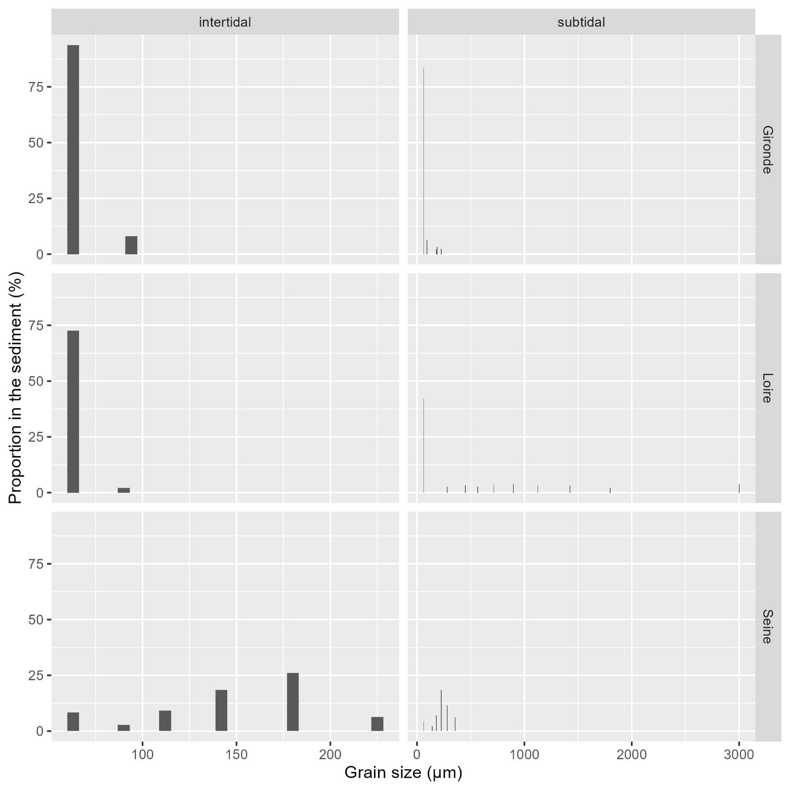

#### Benthic species composition

|  |  |  |  |  |  |  |
| --- | --- | --- | --- | --- | --- | --- |
| ESTUARY | tidal | phylum | class | order | species | abundance_prop |
| Gironde | intertidal | Arthropoda | Crustacea | Multicrustacea | Corophium volutator | 11,38123 |
| Gironde | intertidal | Mollusca | Bivalvia | Autobranchia | Scrobicularia plana | 11,25635 |
| Gironde | intertidal | Mollusca | Gastropoda | Caenogastropoda | Peringia ulvae | 48,12255 |
| Gironde | subtidal | Annelida | Polychaeta | Sedentaria | Heteromastus filiformis | 41,60935 |
| Gironde | subtidal | Arthropoda | Crustacea | Multicrustacea | Mesopodopsis slabberi | 20,83906 |
| Loire | intertidal | Annelida | Polychaeta | Sedentaria | Heteromastus filiformis | 36,23616 |
| Loire | intertidal | Mollusca | Bivalvia | Autobranchia | Scrobicularia plana | 16,21156 |
| Loire | subtidal | Annelida | Polychaeta | Sedentaria | Boccardiella ligerica | 69,68577 |
| Seine | intertidal | Mollusca | Bivalvia | Autobranchia | Cerastoderma edule | 24,90826 |
| Seine | intertidal | Mollusca | Bivalvia | Autobranchia | Macoma balthica | 20,91743 |
| Seine | subtidal | Annelida | Polychaeta | Errantia | Microphthalmus | 28,30508 |
| Seine | subtidal | Arthropoda | Crustacea | Multicrustacea | Haustorius arenarius | 18,47458 |
| Seine | subtidal | Arthropoda | Crustacea | Multicrustacea | Bathyporeia pilosa | 13,38983 |

## References

Amouroux, I. *et al.* (2025) « Emergent’Sea. Recherche des substances d’intérêt émergent en milieu marin », *Ref. Ifremer/RBE/CCEM‐ARC‐15.12.2024*, Contrat R&D OFB 21‐453, p. 61.

Authority (EFSA), E.F.S. (2017) « Peer review of the pesticide risk assessment of the active substance thiram », *EFSA Journal*, 15(7), p. e04700. Disponible sur: https://doi.org/10.2903/j.efsa.2017.4700.

Bacq, N. *et al.* (2013) *Modélisation des fonctions écologiques de l’Estuaire de la Seine et ScENarios d’Evolution (MESSCENE)*. Disponible sur: https://www.seine-aval.fr//wp-content/uploads/2017/01/Bacq-et-al-2013-MESSENE.pdf (Consulté le: 19 février 2026).

Blanc, G. (2025) « Cahier n°2 : le cuivre », *LES CAHIERS METALLIQUES*.

Blanchet, H. *et al.* (2025) *Méthodologie pour la surveillance et l’évaluation du paramètre « Macro-invertébrés benthiques » dans les masses d’eau de transition estuariennes de la façade Manche- Atlantique –*. Disponible sur: https://archimer.ifremer.fr/doc/00887/99923/118418.pdf (Consulté le: 9 juillet 2025).

Borgå, K. *et al.* (2004) « Biological and chemical factors of importance in the bioaccumulation and trophic transfer of persistent organochlorine contaminants in arctic marine food webs », *Environmental Toxicology and Chemistry*, 23(10), p. 2367‑2385.

Borja, A., Franco, J. et Pérez, V. (2000) « A Marine Biotic Index to Establish the Ecological Quality of Soft-Bottom Benthos Within European Estuarine and Coastal Environments », *Marine Pollution Bulletin*, 40(12), p. 1100‑1114. Disponible sur: https://doi.org/10.1016/S0025-326X(00)00061-8.

Borja, A. et Muxika, I. (2005) « Guidelines for the use of AMBI (AZTI’s Marine Biotic Index) in the assessment of the benthic ecological quality », *Marine Pollution Bulletin*, 50(7), p. 787‑789. Disponible sur: https://doi.org/10.1016/j.marpolbul.2005.04.040.

Directive 2013/39/EU (2013) « Directive 2013/39/EU of the European Parliament and of the Council of 12 August 2013 amending Directives 2000/60/EC and 2008/105/EC as regards priority substances in the field of water policy », *Official Journal of the European Union*. L 226, 1-17. Disponible sur: https://eur-lex.europa.eu/eli/reg/2022/2002/oj/eng.

Du, B. *et al.* (2019) « Acute toxicity of the fungicide azoxystrobin on the diatom *Phaeodactylum tricornutum* », *Ecotoxicology and Environmental Safety*, 168, p. 72‑79. Disponible sur: https://doi.org/10.1016/j.ecoenv.2018.10.074.

European Commission (2013) *DIRECTIVE 2013/39/EU OF THE EUROPEAN PARLIAMENT AND OF THE COUNCIL of 12 August 2013 amending Directives 2000/60/EC and 2008/105/EC as regards priority substances in the field of water policy. Annex II ENVIRONMENTAL QUALITY STANDARDS FOR PRIORITY SUBSTANCES AND CERTAIN OTHER POLLUTANTS*. Disponible sur: https://eur-lex.europa.eu/eli/dir/2013/39/oj/eng (Consulté le: 2 juillet 2025).

Fisk, A.T. *et al.* (1998) « Dietary accumulation and depuration of hydrophobic organochlorines: Bioaccumulation parameters and their relationship with the octanol/water partition coefficient », *Environmental Toxicology and Chemistry*, 17(5), p. 951‑961. Disponible sur: https://doi.org/10.1897/1551-5028(1998)017<0951:DAADOH>2.3.CO;2.

Fouet, M. *et al.* (2018) *Sélection d’un indicateur DCE « faune benthique invertébrée » adapté aux estuaires*. DOC00085633. Agence française pour la biodiversité - AFB, Université de Bordeaux Irstea, p. 77. Disponible sur: https://professionnels.ofb.fr/fr/doc/selection-dun-indicateur-dce-faune-benthique-invertebree-adapte-aux-estuaires (Consulté le: 8 juillet 2025).

Fouet, M., Blanchet, H. et Lepage, M. (2020) *Intercalibration of biological elements for French transitional water bodies: benthic invertebrates*. Water framework directive.

Hano, T. *et al.* (2022) « Molting enhances internal concentrations of fipronil and thereby decreases survival of two estuarine resident marine crustaceans », *Aquatic Toxicology*, 247, p. 106172. Disponible sur: https://doi.org/10.1016/j.aquatox.2022.106172.

Hawker, D.W. et Connell, D.W. (1988) « Octanol-water partition coefficients of polychlorinated biphenyl congeners », *Environmental Science & Technology*, 22(4), p. 382‑387. Disponible sur: https://doi.org/10.1021/es00169a004.

Hindarti, D. et Larasati, A.W. (2019) « Copper (Cu) and Cadmium (Cd) toxicity on growth, chlorophyll-a and carotenoid content of phytoplankton Nitzschia sp », *IOP Conference Series: Earth and Environmental Science*, 236(1), p. 012053. Disponible sur: https://doi.org/10.1088/1755-1315/236/1/012053.

Ifremer (2021) *20 ans de suivi de la contamination chimique des eaux côtières méditerranéennes : Résultats et perspectives*. Disponible sur: https://archimer.ifremer.fr/doc/00673/78554/80744.pdf (Consulté le: 2 juillet 2025).

Ifremer (2024) *Qualité du Milieu Marin Littoral. Bulletin de la surveillance 2023. Départements de la Gironde, des Landes et des Pyrénées atlantiques.* Laboratoire Environnement Ressources d’Arcachon/Anglet. Ref. ODE/COAST/LERAR/24.013. Ifremer, p. 194. Disponible sur: https://archimer.ifremer.fr/doc/00924/103575/ (Consulté le: 3 juillet 2025).

Ifremer (2025) *Qualité du Milieu Marin Littoral. Bulletin de la surveillance 2024. Départements de la Loire Atlantique et Vendée (partie nord).* Laboratoire Environnement Ressources MPL/NT. Ref. ODE/COAST/LER MPL/2025.06. Ifremer, p. 176. Disponible sur: https://archimer.ifremer.fr/doc/00953/106531/ (Consulté le: 3 juillet 2025).

Ineris (2022) *Bilan annuel des travaux sur la thématique « substances dangereuses » dans le cadre de la convention OSPAR pour la protection et la préservation de l’Atlantique Nord-Est et ses ressources*. Disponible sur: https://www.ineris.fr/sites/ineris.fr/files/contribution/Documents/Suivi%20des%20travaux%20OSPAR%20%7B6%7Dsubstances%20dangereuses%7B6%7D%20v1.pdf.

Jung, S.M. *et al.* (2017) « Acute toxicity of organic antifouling biocides to phytoplankton *Nitzschia pungens* and zooplankton *Artemia* larvae », *Marine Pollution Bulletin*, 124(2), p. 811‑818. Disponible sur: https://doi.org/10.1016/j.marpolbul.2016.11.047.

Kelly, B.C. *et al.* (2008) « Bioaccumulation behaviour of polybrominated diphenyl ethers (PBDEs) in a Canadian Arctic marine food web », *Science of The Total Environment*, 401(1), p. 60‑72. Disponible sur: https://doi.org/10.1016/j.scitotenv.2008.03.045.

Lebrun, J. *et al.* (2022) « Screening Potential Toxicity of Currently Used Herbicides in the Freshwater Amphipod Gammarus Fossarum Based on Multi-Level Biomarker Responses to Field-Realistic Exposures », 18 octobre. Disponible sur: https://papers.ssrn.com/abstract=4250863 (Consulté le: 30 juillet 2025).

Légifrance (2023) *Article 3 de l’arrêté du 9 octobre 2023 modifiant l’arrêté du 25 janvier 2010 relatif aux méthodes et critères d’évaluation de l’état écologique, de l’état chimique et du potentiel écologique des eaux de surface pris en application des article R. 212-10, R. 212-11 et R. 212-18 du code de l’environnement.* Disponible sur: https://www.legifrance.gouv.fr/jorf/id/JORFTEXT000048347187 (Consulté le: 2 juillet 2025).

legifrance.gouv (2023) *Arrêté du 9 octobre 2023 modifiant l’arrêté du 25 janvier 2010 relatif aux méthodes et critères d’évaluation de l’état écologique, de l’état chimique et du potentiel écologique des eaux de surface pris en application des article R. 212-10, R. 212-11 et R. 212-18 du code de l’environnement - Légifrance*. Disponible sur: https://www.legifrance.gouv.fr/jorf/id/JORFSCTA000048347211?utm_source=chatgpt.com (Consulté le: 17 mai 2025).

Liu, K. *et al.* (2022) « Thiram exposure in environment: A critical review on cytotoxicity », *Chemosphere*, 295, p. 133928. Disponible sur: https://doi.org/10.1016/j.chemosphere.2022.133928.

van Loon, W.M.G.M. *et al.* (2015) « Application of the Benthic Ecosystem Quality Index 2 to benthos in Dutch transitional and coastal waters », *Journal of Sea Research*, 103, p. 1‑13. Disponible sur: https://doi.org/10.1016/j.seares.2015.05.002.

Luo, H.-W. *et al.* (2023) « Water quality criteria derivation and tiered ecological risk evaluation of antifouling biocides in marine environment », *Marine Pollution Bulletin*, 187, p. 114500. Disponible sur: https://doi.org/10.1016/j.marpolbul.2022.114500.

Martínez-Gómez, C. *et al.* (2009) « Evaluation of three-year monitoring with biomarkers in fish following the Prestige oil spill (N Spain) », *Chemosphere*, 74(5), p. 613‑620. Disponible sur: https://doi.org/10.1016/j.chemosphere.2008.10.052.

Martins, S.E. *et al.* (2018) « Review: ecotoxicity of organic and organo-metallic antifouling co-biocides and implications for environmental hazard and risk assessments in aquatic ecosystems », *Biofouling*, 34(1), p. 34‑52. Disponible sur: https://doi.org/10.1080/08927014.2017.1404036.

OSPAR (2023a) *Status and trend for heavy metals (Mercury, Cadmium and Lead) in fish, shellfish and sediment*. Disponible sur: https://oap.ospar.org/en/ospar-assessments/quality-status-reports/qsr-2023/indicator-assessments/heavy-metals-biota-sediment/ (Consulté le: 3 juillet 2025).

OSPAR (2023b) *Status and Trends in the Concentrations of Polycyclic Aromatic Hydrocarbons (PAHs) in Shellfish and Sediment*. Disponible sur: https://oap.ospar.org/en/ospar-assessments/quality-status-reports/qsr-2023/indicator-assessments/pah-shellfish-sediment/ (Consulté le: 3 juillet 2025).

OSPAR (2023c) *Status and Trends in the Levels of Imposex in Marine Gastropods (TBT in Shellfish)*. Disponible sur: https://oap.ospar.org/en/ospar-assessments/quality-status-reports/qsr-2023/indicator-assessments/tbt-shellfish/ (Consulté le: 3 juillet 2025).

OSPAR (2023d) *Status and Trends of Polychlorinated Biphenyls (PCB) in Fish, Shellfish and Sediment*. Disponible sur: https://oap.ospar.org/en/ospar-assessments/quality-status-reports/qsr-2023/indicator-assessments/pcb-biota-sediment/ (Consulté le: 3 juillet 2025).

Qiu, T. *et al.* (2022) « Long-term exposure to azoxystrobin induces immunodeficiency in fish that are vulnerable to subsequent rhabdovirus infection », *Ecotoxicology and Environmental Safety*, 248, p. 114331. Disponible sur: https://doi.org/10.1016/j.ecoenv.2022.114331.

Rebelo, D., Antunes, S.C. et Rodrigues, S. (2023) « The Silent Threat: Exploring the Ecological and Ecotoxicological Impacts of Chlorinated Aniline Derivatives and the Metabolites on the Aquatic Ecosystem », *Journal of Xenobiotics*, 13(4), p. 604‑614. Disponible sur: https://doi.org/10.3390/jox13040038.

Rodrigues, E.T., Lopes, I. et Pardal, M.Â. (2013) « Occurrence, fate and effects of azoxystrobin in aquatic ecosystems: A review », *Environment International*, 53, p. 18‑28. Disponible sur: https://doi.org/10.1016/j.envint.2012.12.005.

Sardo, A.M. *et al.* (2005) « Histological evaluation of the exposure to 3,4-dichloroaniline in estuarine mysid Mesopodopsis slabberi, under experimental conditions », *Fresenius Environmental Bulletin*, 14(7).

Sautour, B. et Baron, J. (éd.) (2020) *L’estuaire de la Gironde : un écosystème altéré ? : Entre dynamique naturelle et pressions anthropiques*, *L’estuaire de la Gironde : un écosystème altéré ? : Entre dynamique naturelle et pressions anthropiques*. Pessac: Presses Universitaires de Bordeaux (À la croisée des sciences). Disponible sur: https://books.openedition.org/pub/44868 (Consulté le: 29 juillet 2025).

Soloperto, S. *et al.* (2022) « Development of an exposure protocol for toxicity test (FEET) for a marine species: the European sea bass (Dicentrarchus labrax) », *Environmental Science and Pollution Research*, 29(11), p. 15777‑15790. Disponible sur: https://doi.org/10.1007/s11356-021-16785-z.

Walker, M.K. et Peterson, R.E. (1994) « Aquatic Toxicity of Dioxins and Related Chemicals », in A. Schecter (éd.) *Dioxins and Health*. Boston, MA: Springer US, p. 347‑387. Disponible sur: https://doi.org/10.1007/978-1-4899-1462-0_11.

Wright, D.A. et Welbourn, P.M. (1994) « Cadmium in the aquatic environment: a review of ecological, physiological, and toxicological effects on biota », *Environmental Reviews*, 2(2), p. 187‑214. Disponible sur: https://doi.org/10.1139/a94-012.